**JOHN J. BURNS LIBRARY CONSERVATION TREATMENT REPORT**

**Conservator** Hebard, report written by Kim (student intern) **Date** July 11, 2017

**Report number** 2017.015

**Call number** Stacks Unit One DH186.G34 1677b JESUITANA prima pars and pars altera

**Author** Galluccio Angelo SJ

**Title** Angeli Galluccii e Societate Jesu De bello Belgico : ab anno Christi MDXCII, ad inducias annorum XI

**Place of Publication** Nuremberg

**Date of Publication** 1677 **Acc. No. barcode #** B966238 (prima pars), B966239 (pars   
 altera)

**CONDITION**

**Binding** Brown mottled full sheepskin leather tight-back binding. Boards showing areas of abrasion; worn board   
 edges on the fore-edge and tail of the boards; corners bumped inwards. Some leather loss in both head and   
 tail joints. Spine panels gilt; top, fourth, fifth, and sixth panels gilt with solid double rule border with Aldus   
 style tools and central gilt flower motif. Second and third panels are lettering pieces with original colors red   
 and green faded; second panel lettering piece gilt with solid gold double rule border; third panel lettering   
 piece gilt “TOM. I.” on prima pars, and “TOM. II.” on pars altera with solid gold double rule border with   
 alternating fleur-de-lis and dot pattern. prima pars: A patch lighter brown discoloration of leather on front   
 board; small leather with tear torn due to abrasion on front board. All boards slightly warped due to possible   
 water damage. Third panel lettering piece lifting slightly on bottom right corner.

**Text paper** Off-white laid paper. Prima pars has title page; printed in both black and red ink. Tide lines are present.   
 Insect stains are present on title page of prima pars.

**Endpapers** Red and blue flower patterned endpapers stamped with wooden blocks. Prima pars has endpapers attached   
 in both front and back of book. Pars altera has a red leather label with gold gilt “EX LIBRIS CARLO DE   
 POORTERE”

**Sewing** Intact; over 5 cords.

**Forwarding** All edges colored red. Thin blue slightly fraying ribbon bookmarks. Two colored endbands (light blue and   
 cream colors).

**TREATMENT**

**Spot tests** N/A

**Paper repairs** N/A

**Forwarding treatment** The boards, spine, edges of text block, and end papers were surfaced cleaned first with graphite brush and   
 then Gonzo sponge.

**Binding repair** One board corner was re-laminated with wheat starch paste. All board corners were evened out with wheat   
 starch paste inserted with syringe and dried overnight with wax paper, blotters, and Davey boards, between   
 binder clips. A dot of PVA was used to glue down a small loose leather piece. Leather dressing (Klucel-G   
 and ethanol) was brushed on all leather binding and the spine.

**Protective housing** N/A

**Photographic record**

Before:

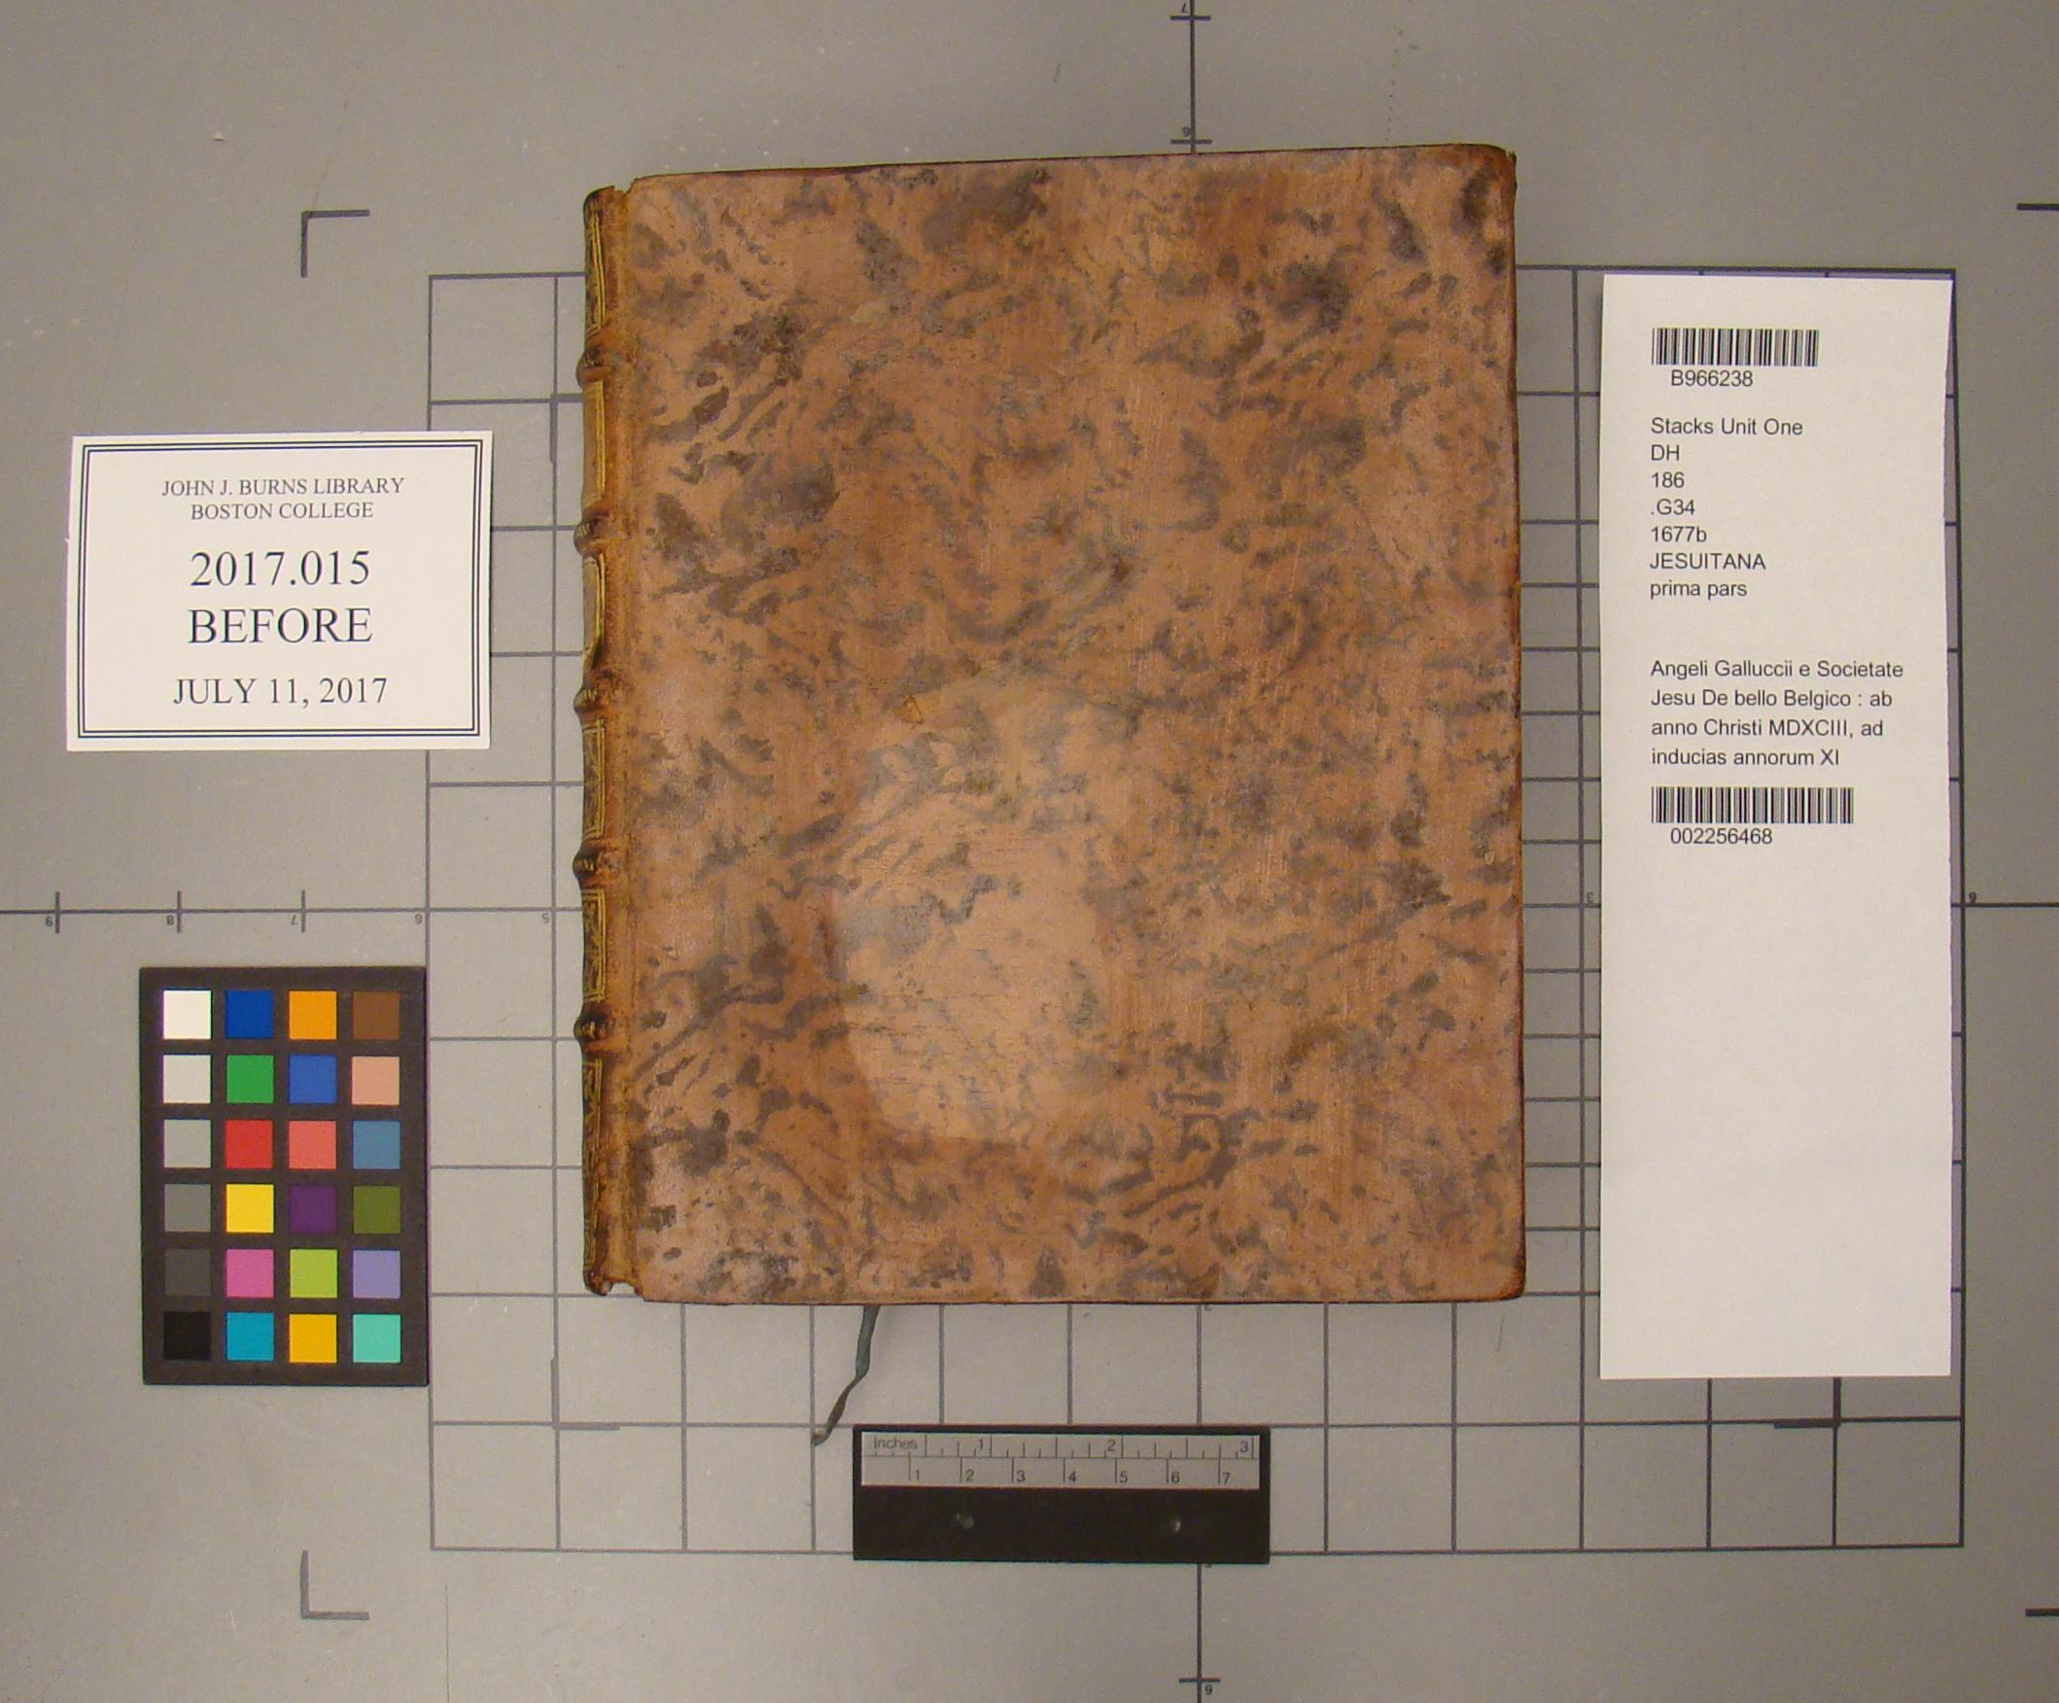

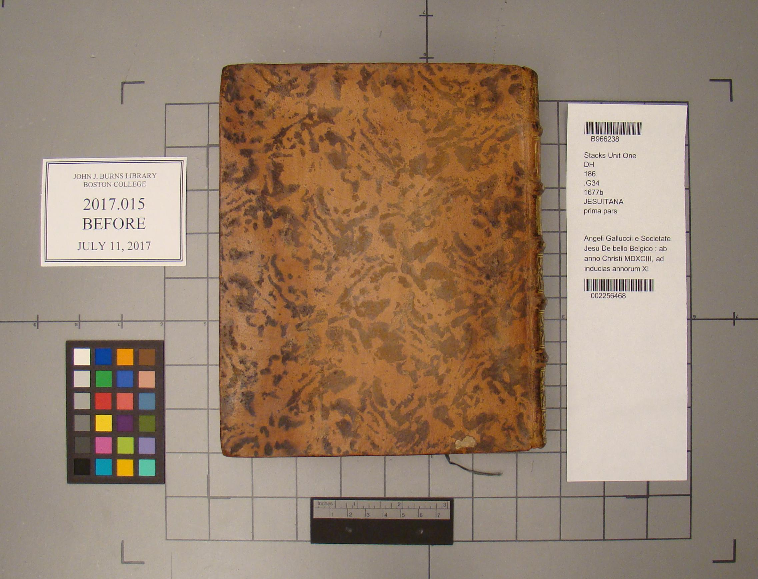

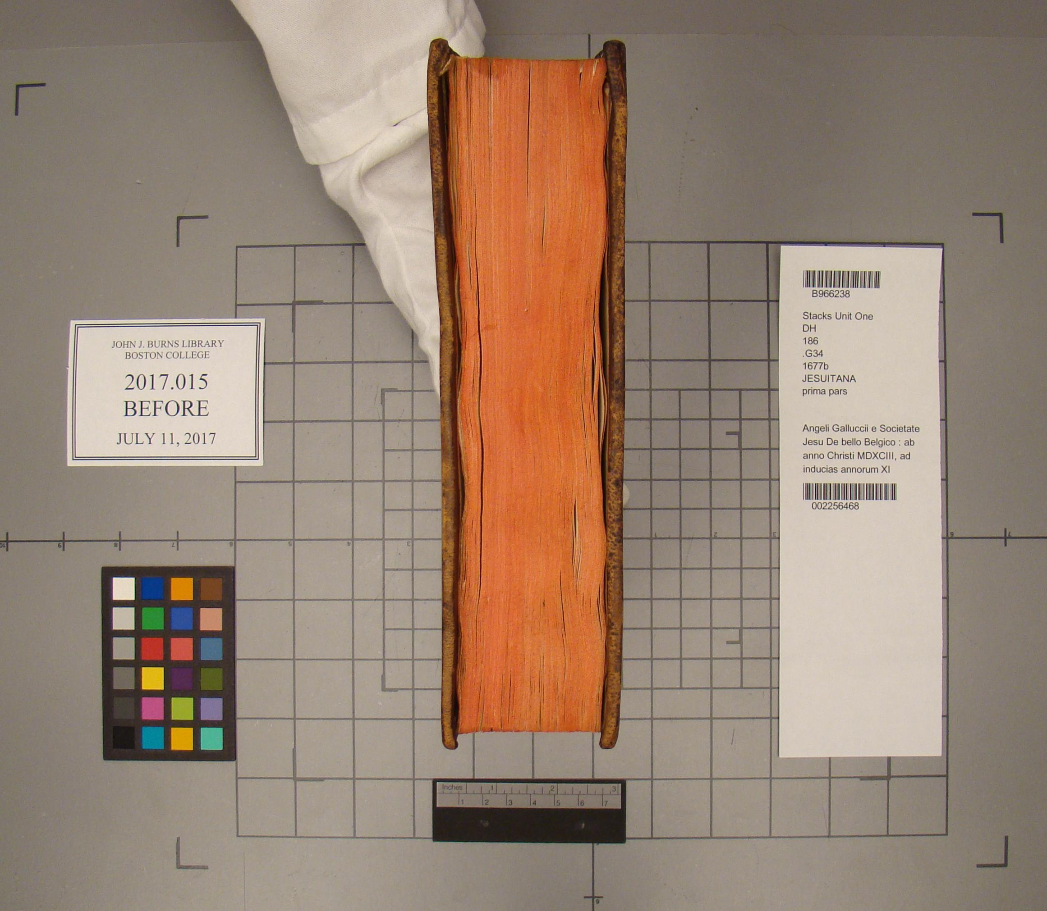

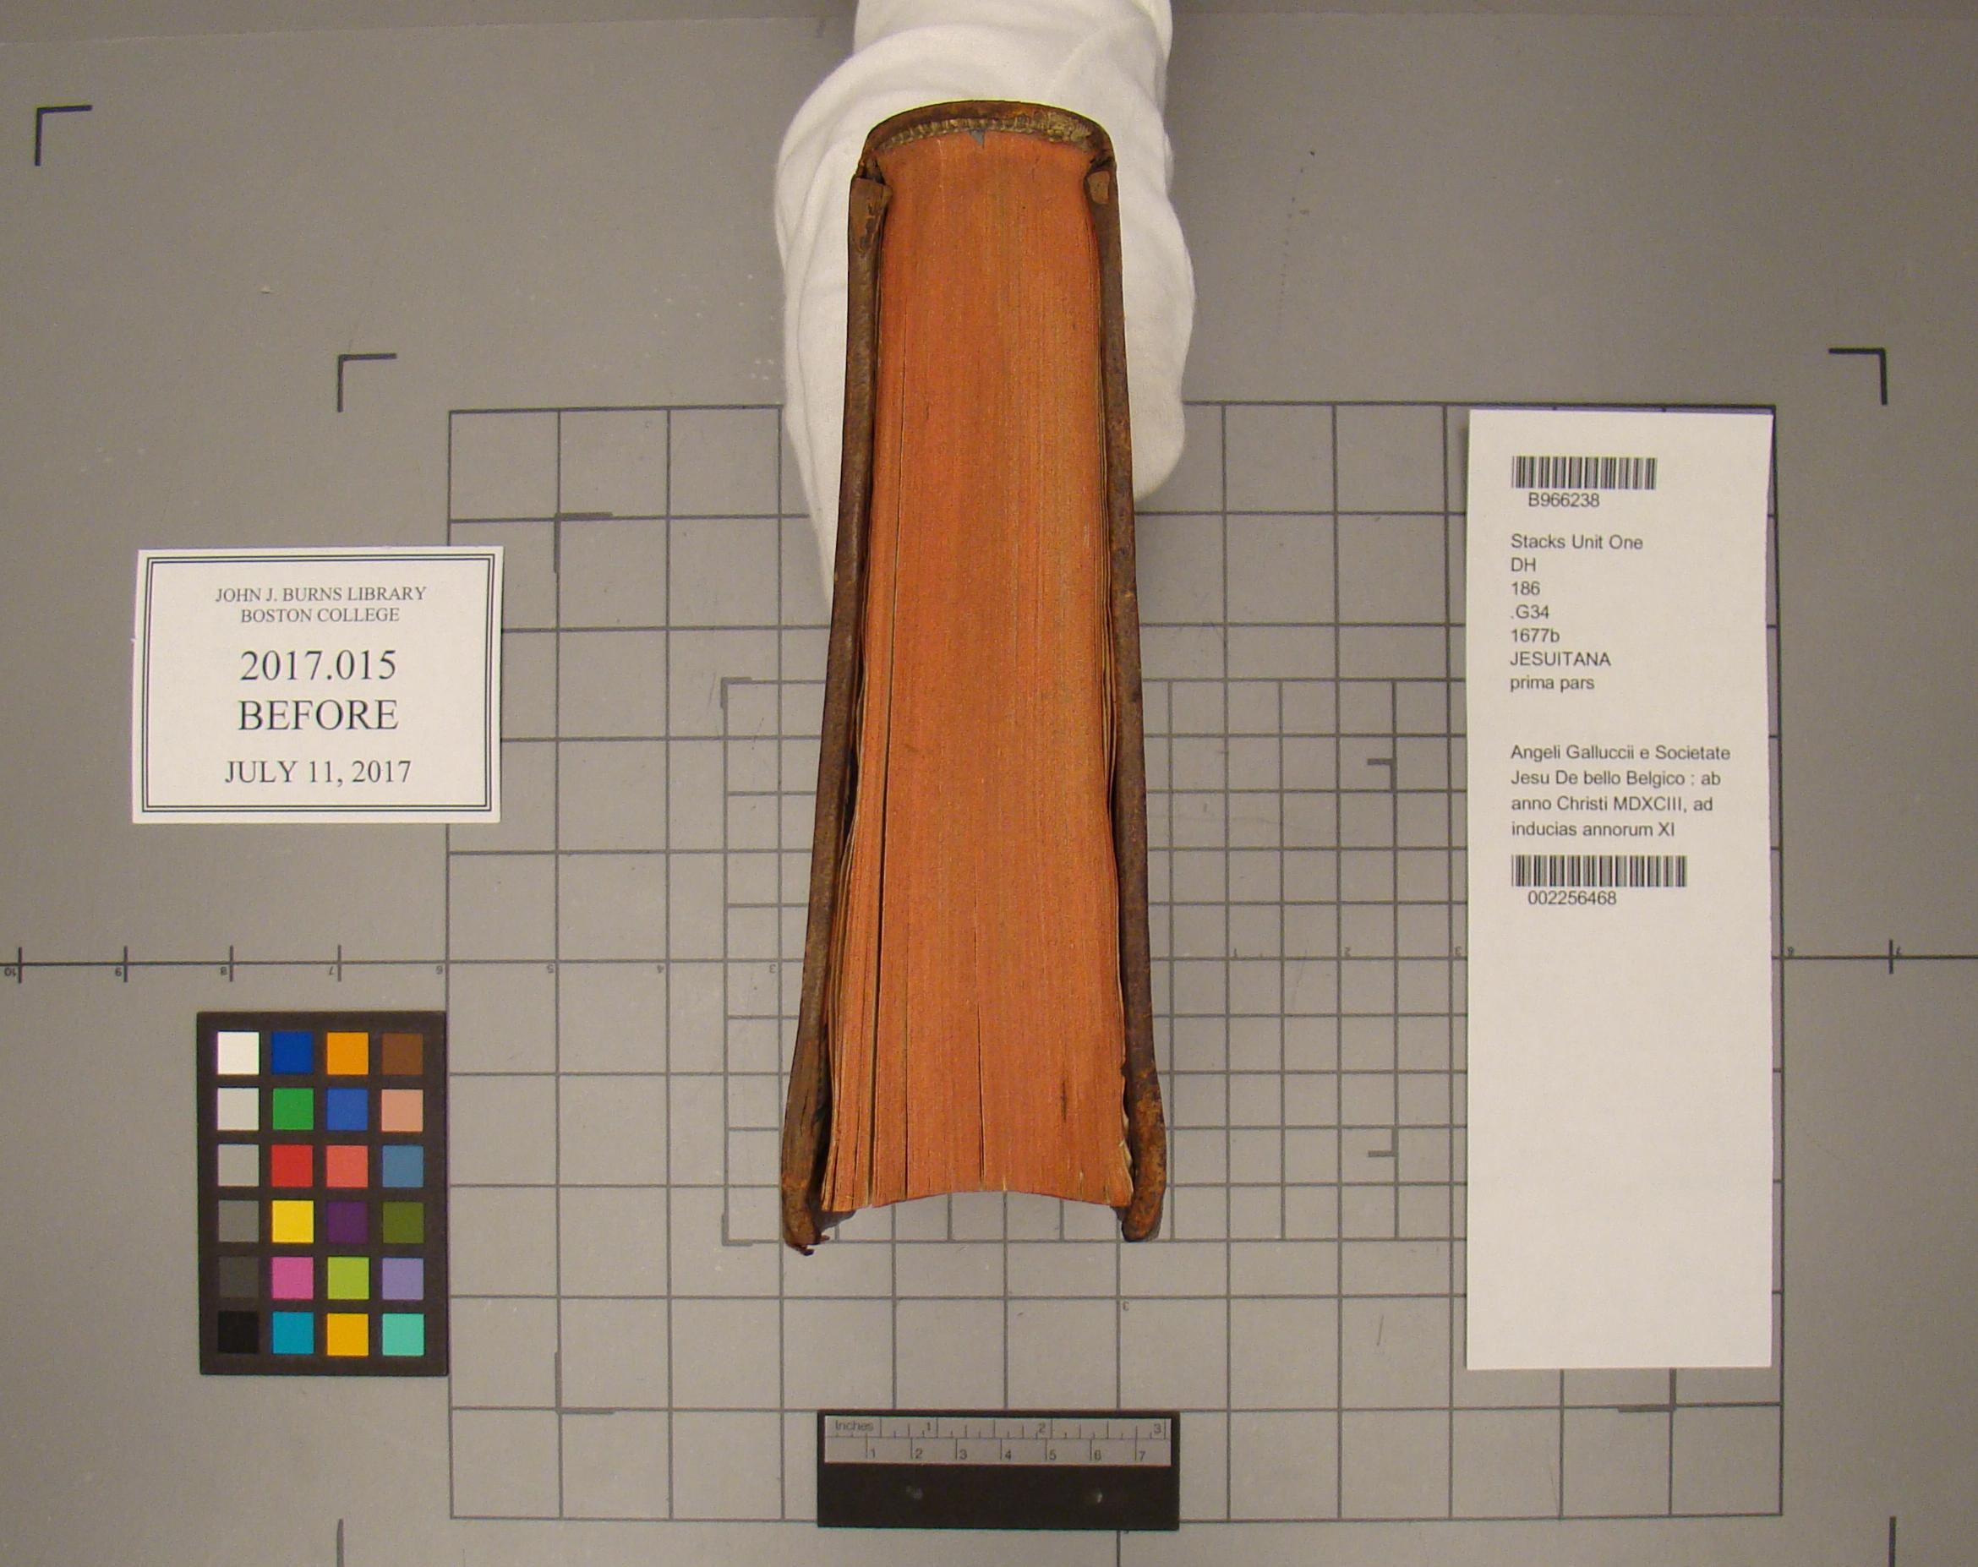

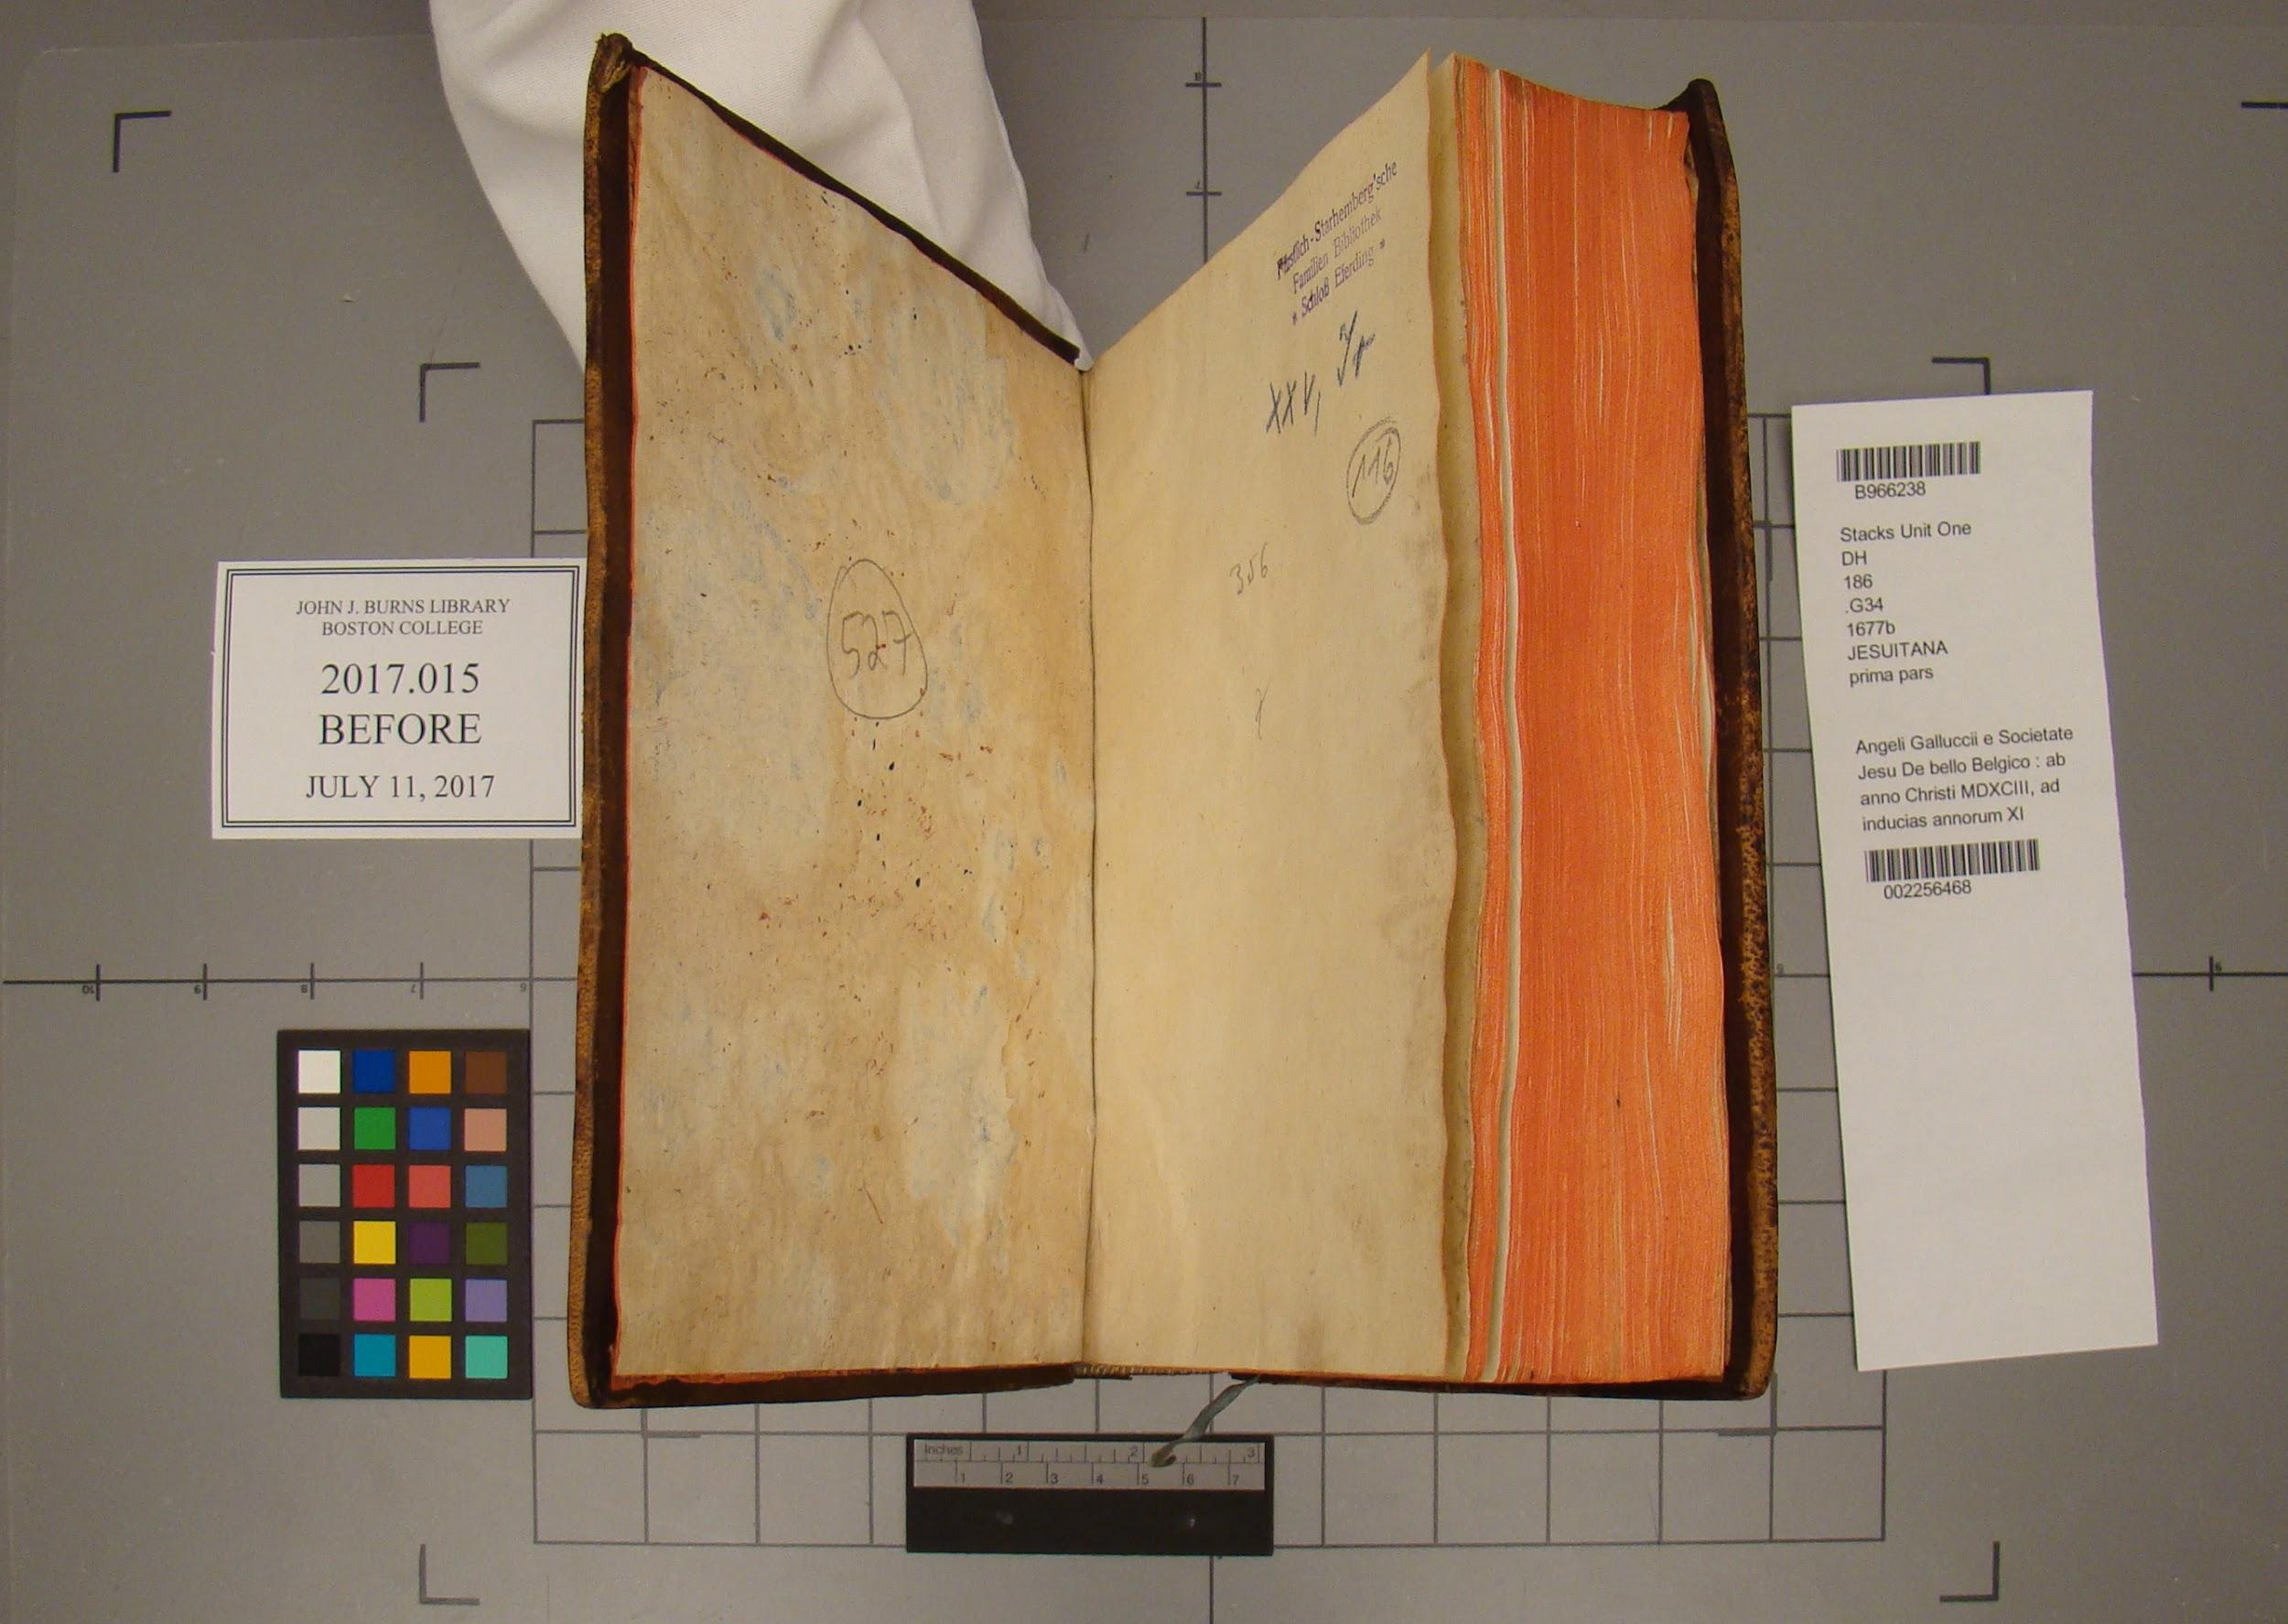

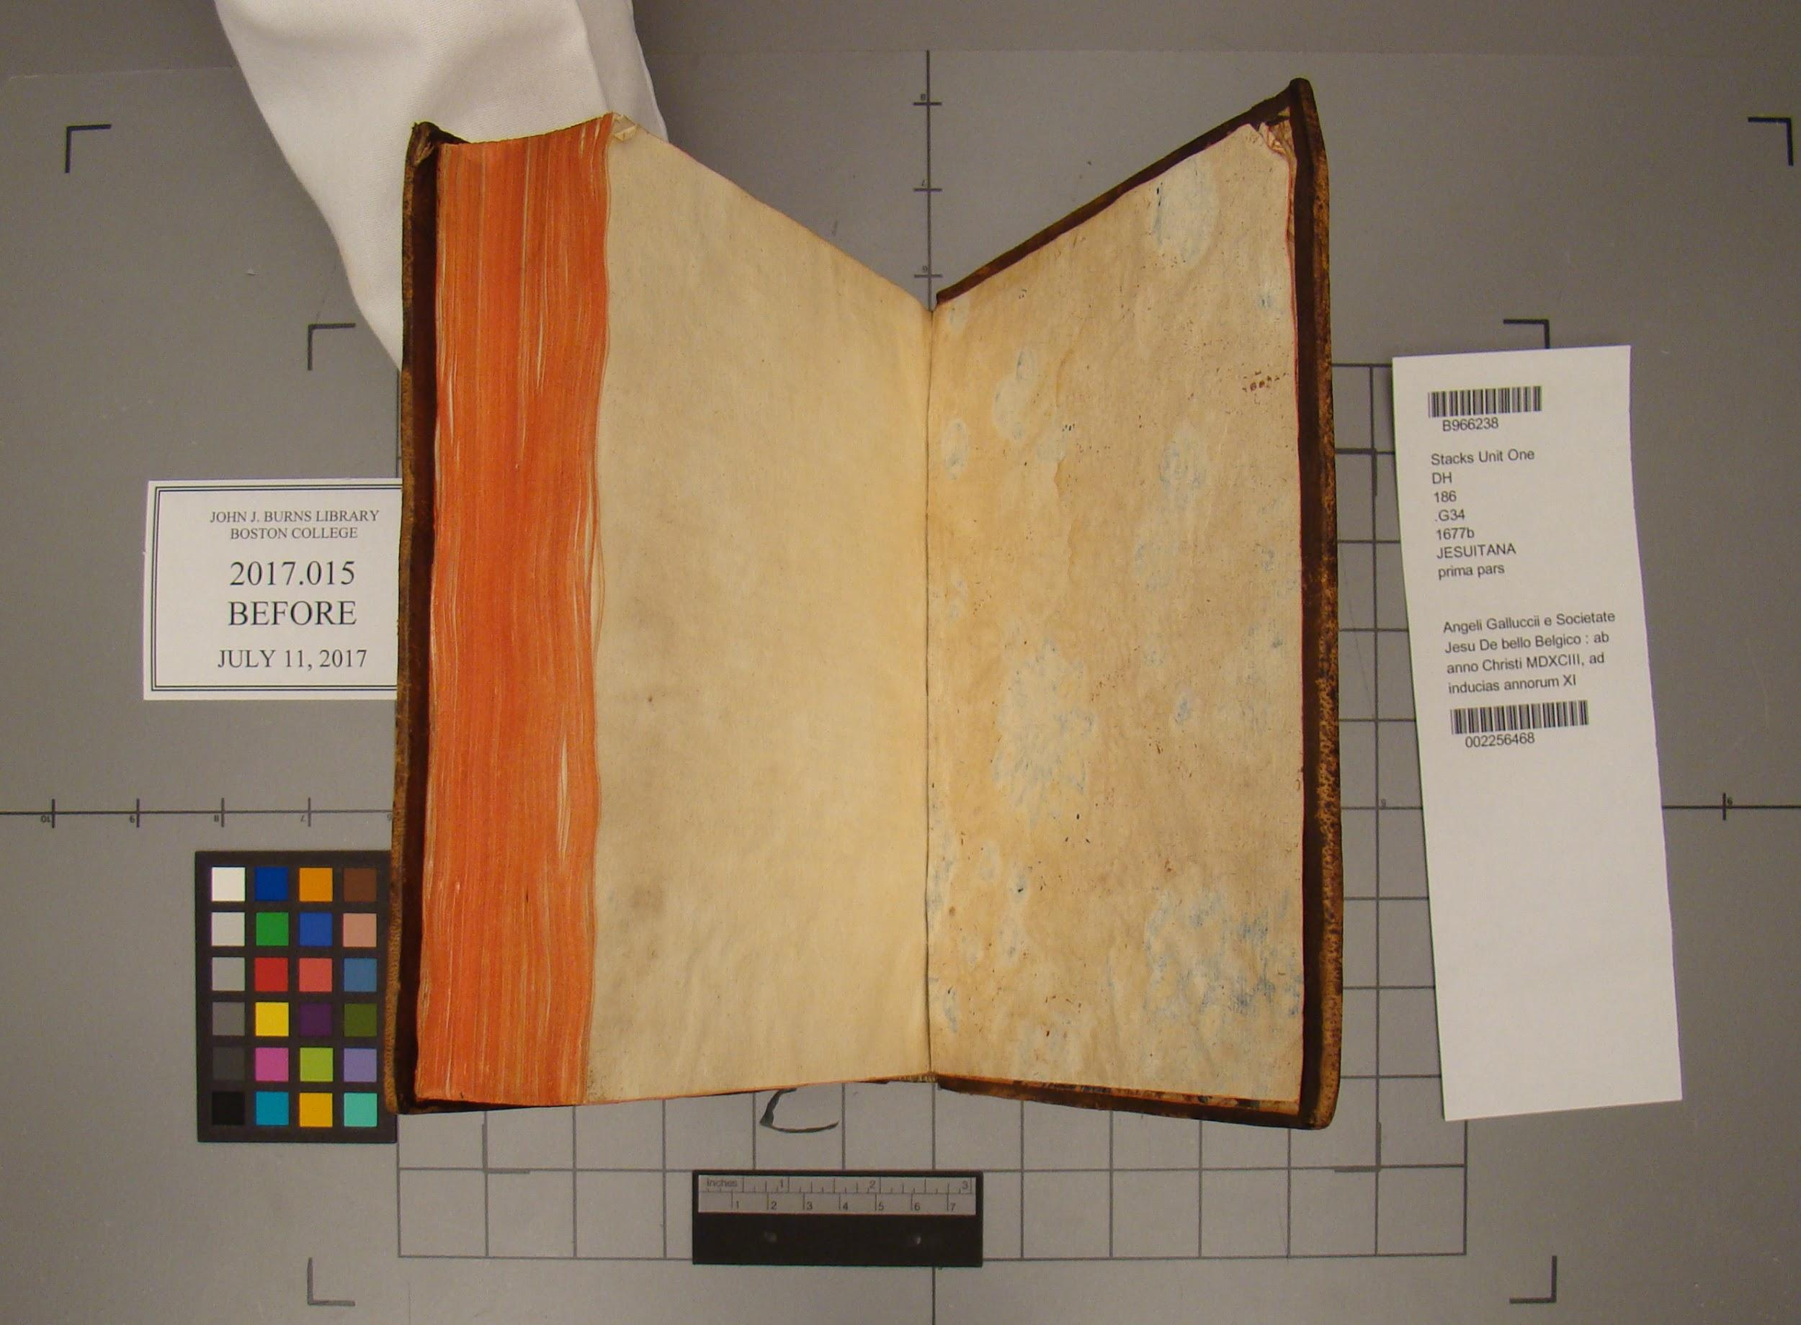

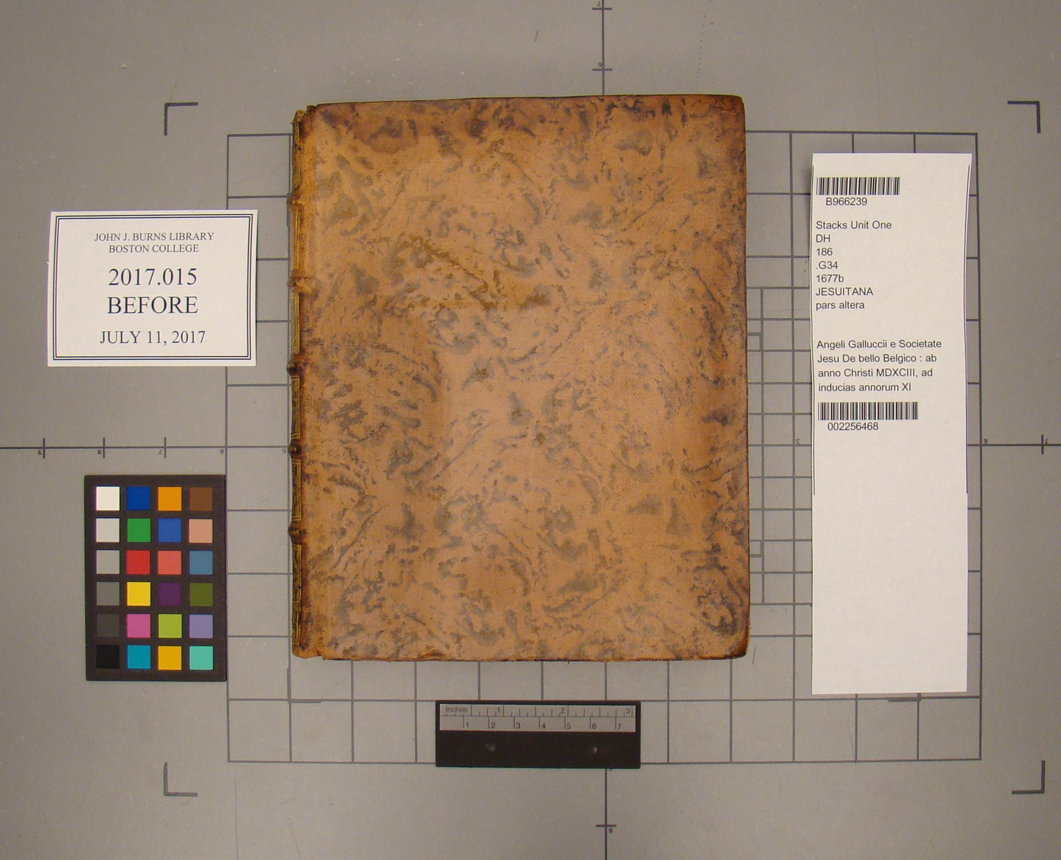

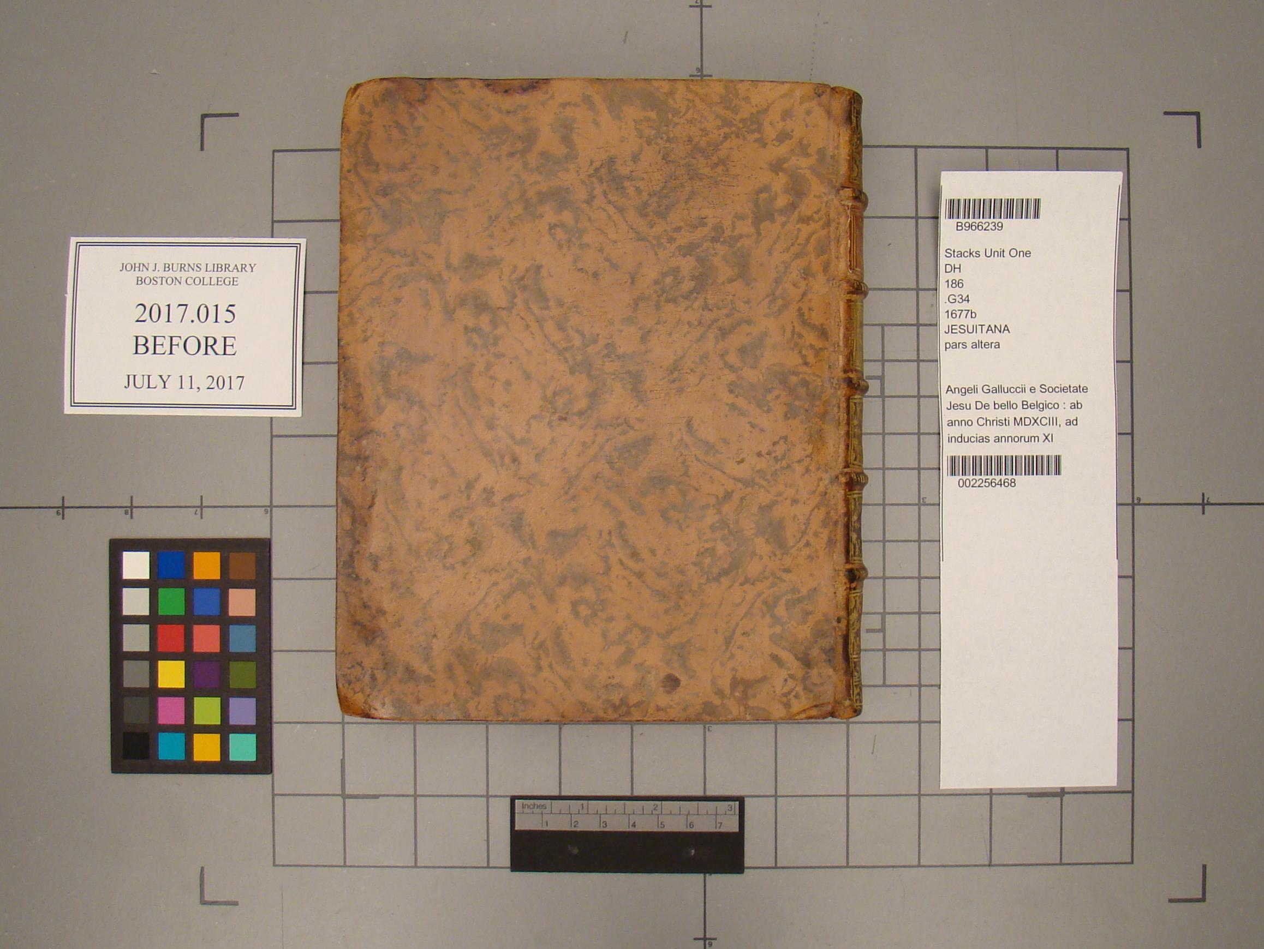

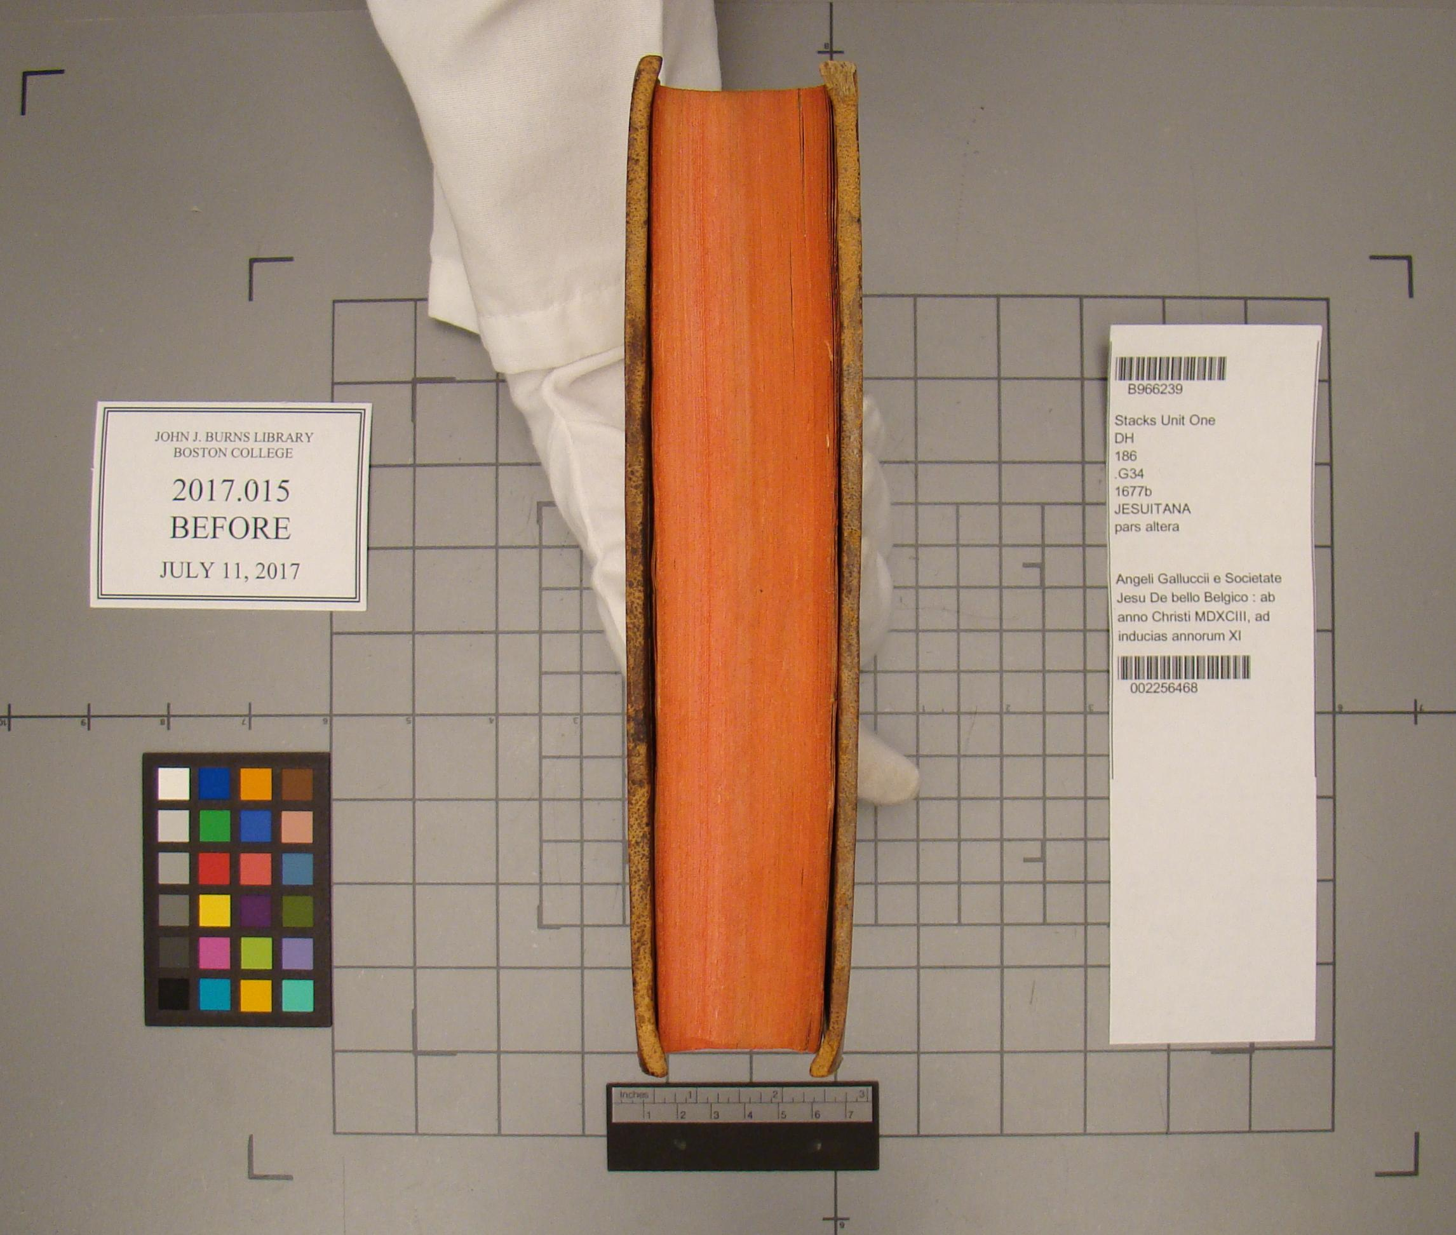

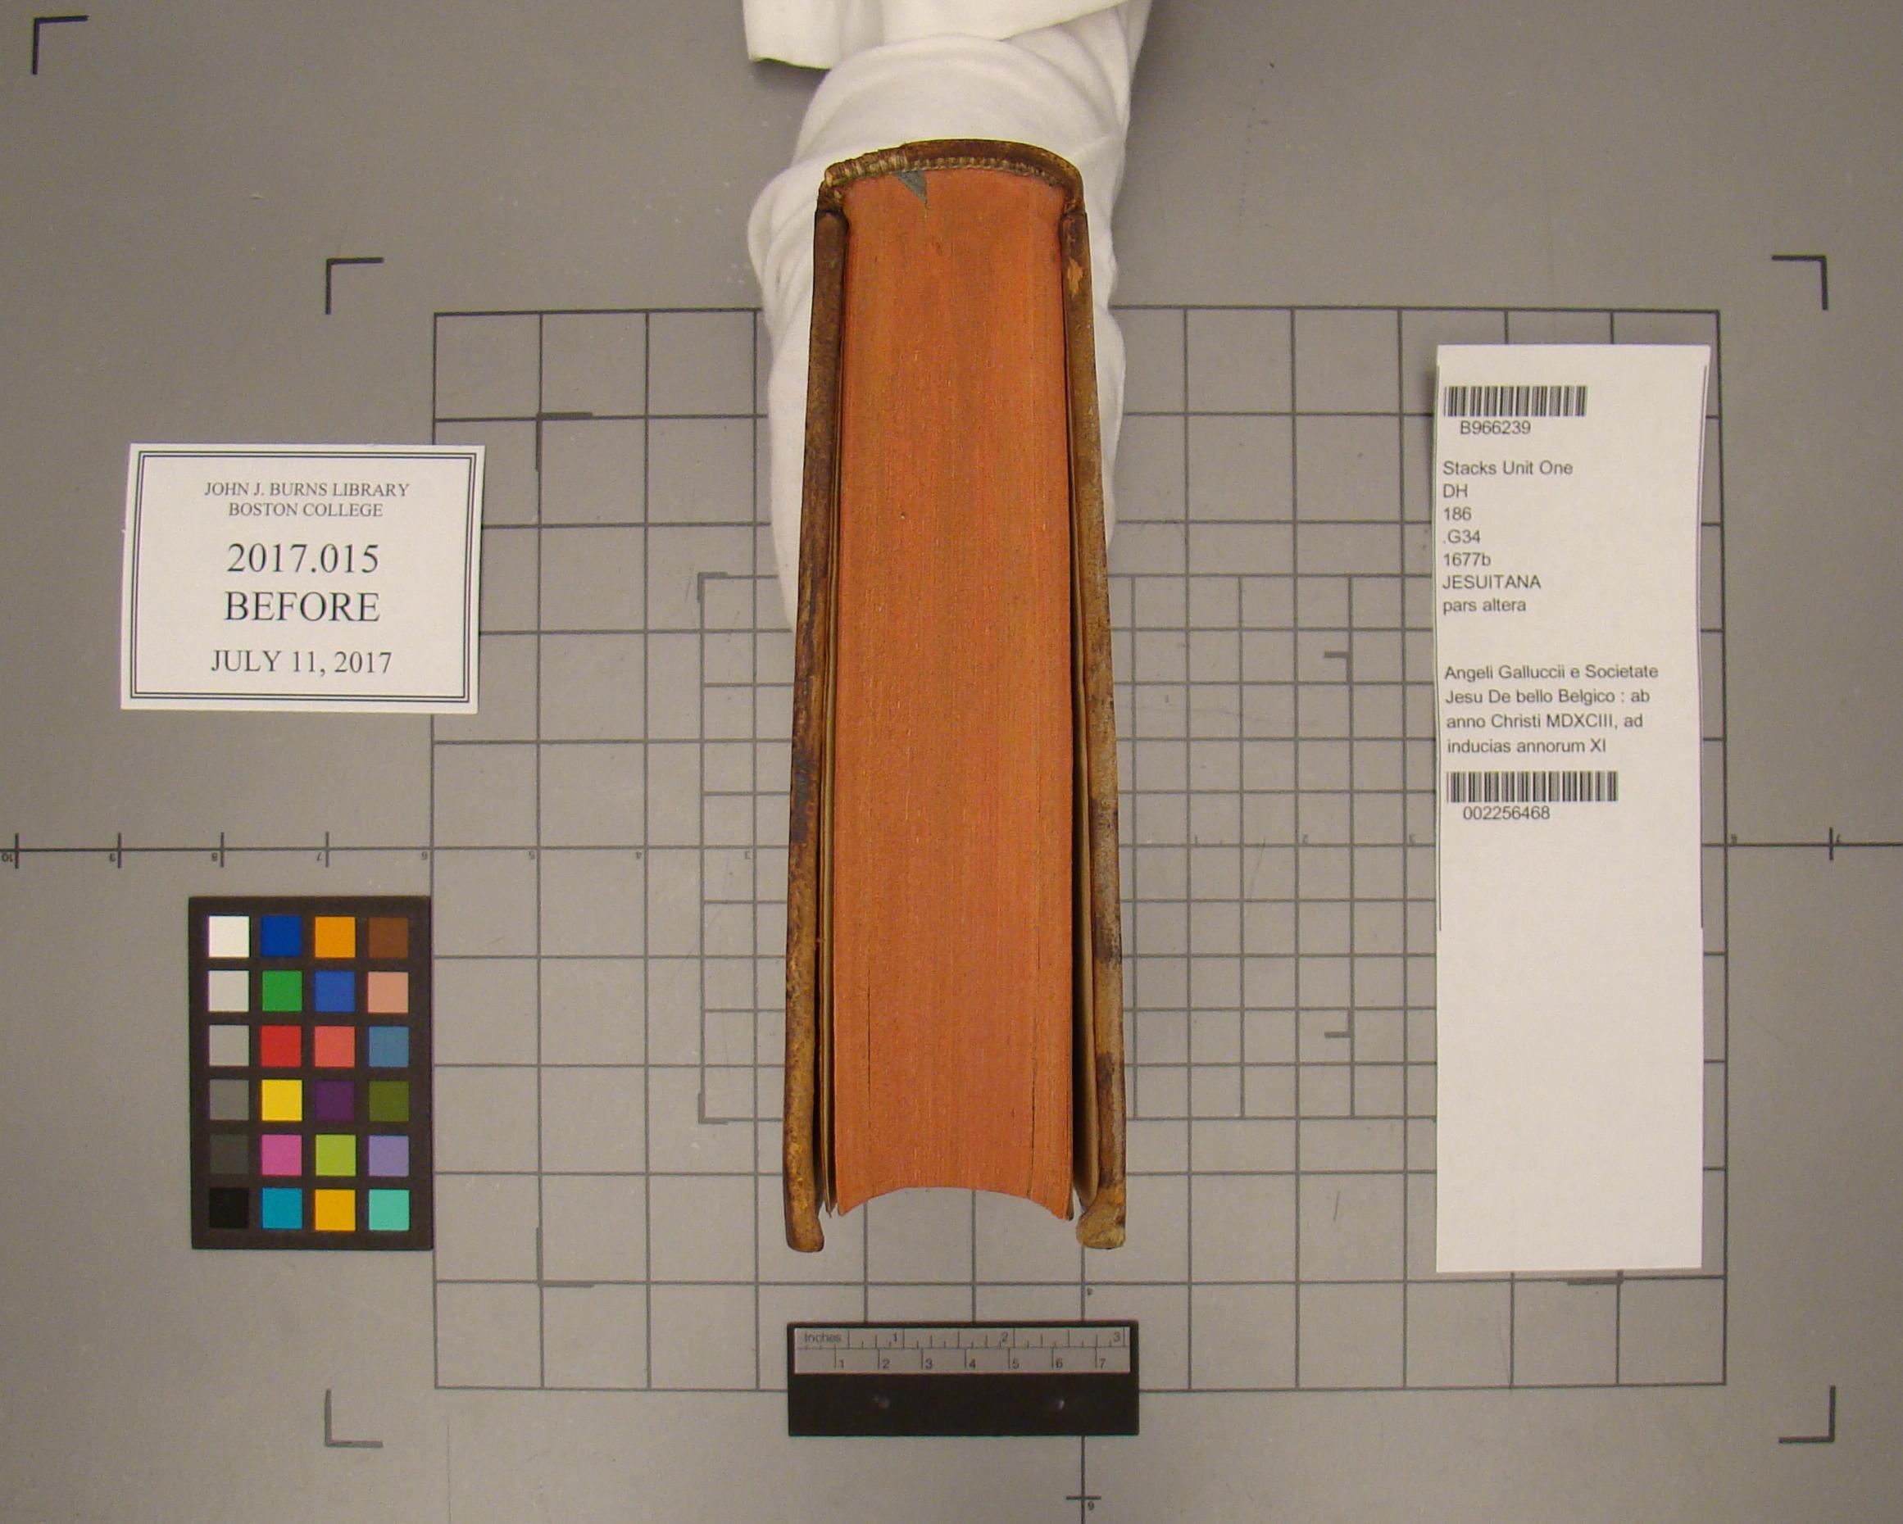

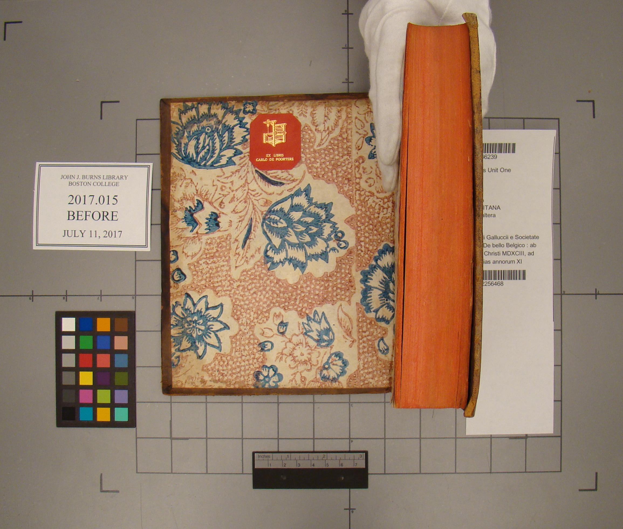

During:

**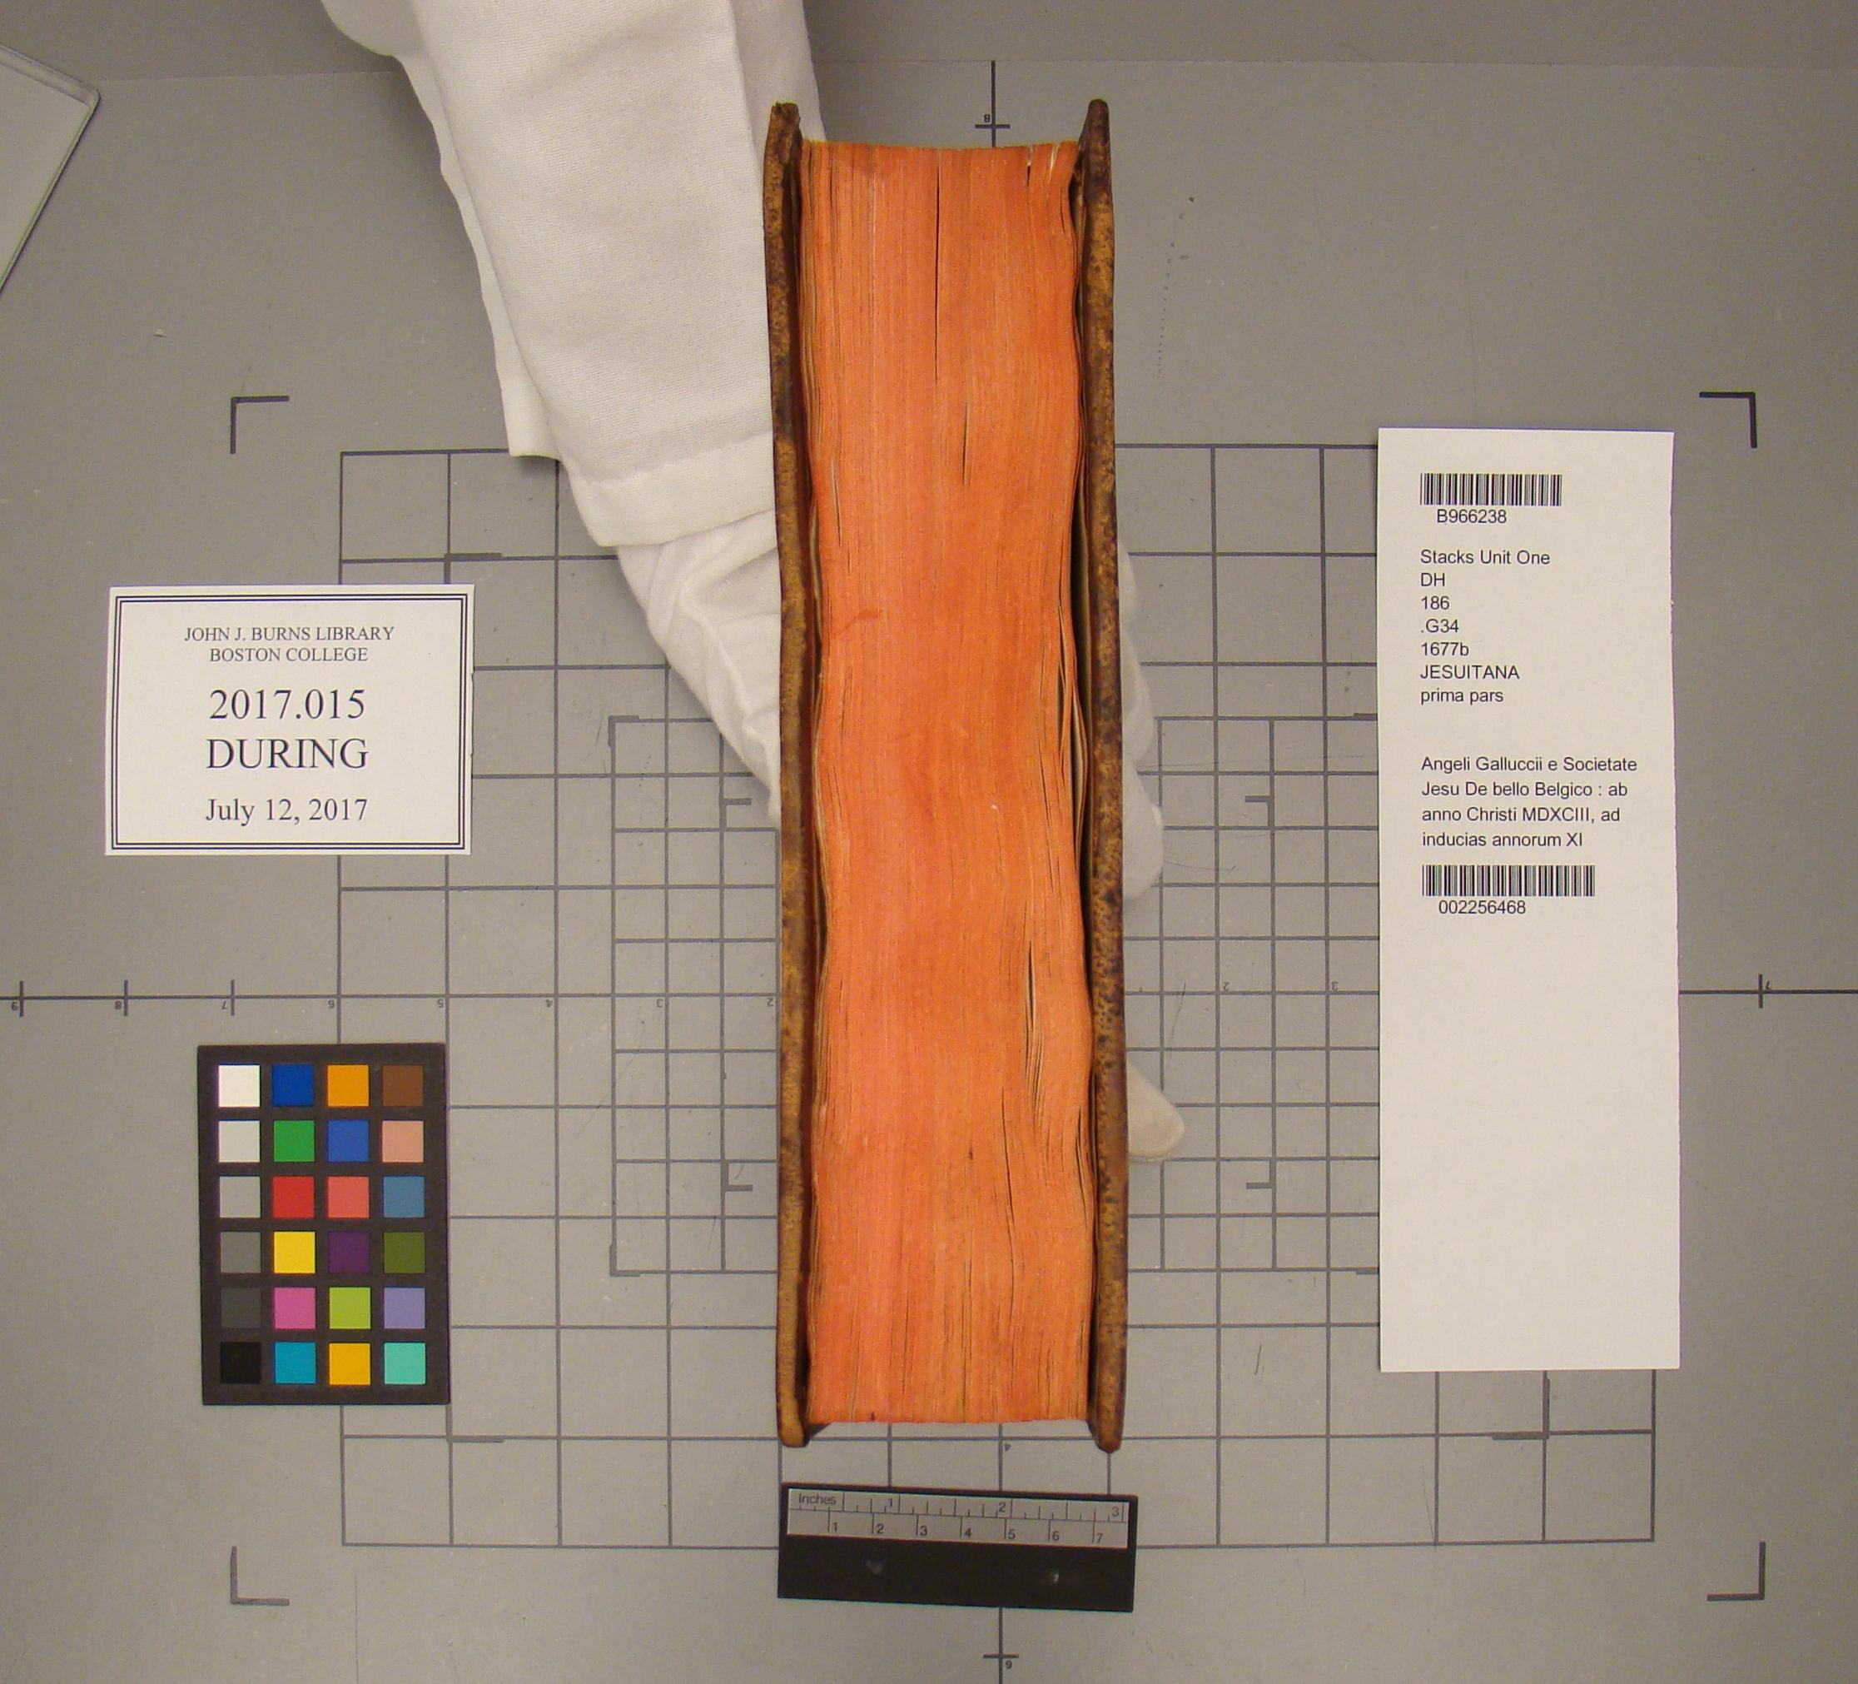  
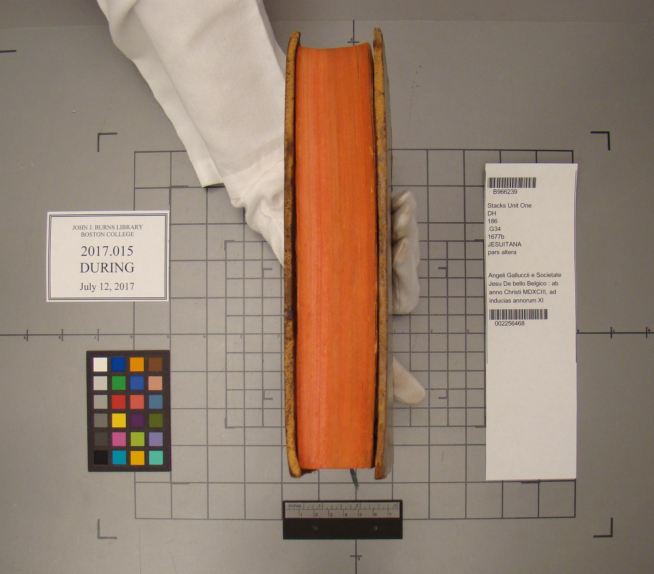**

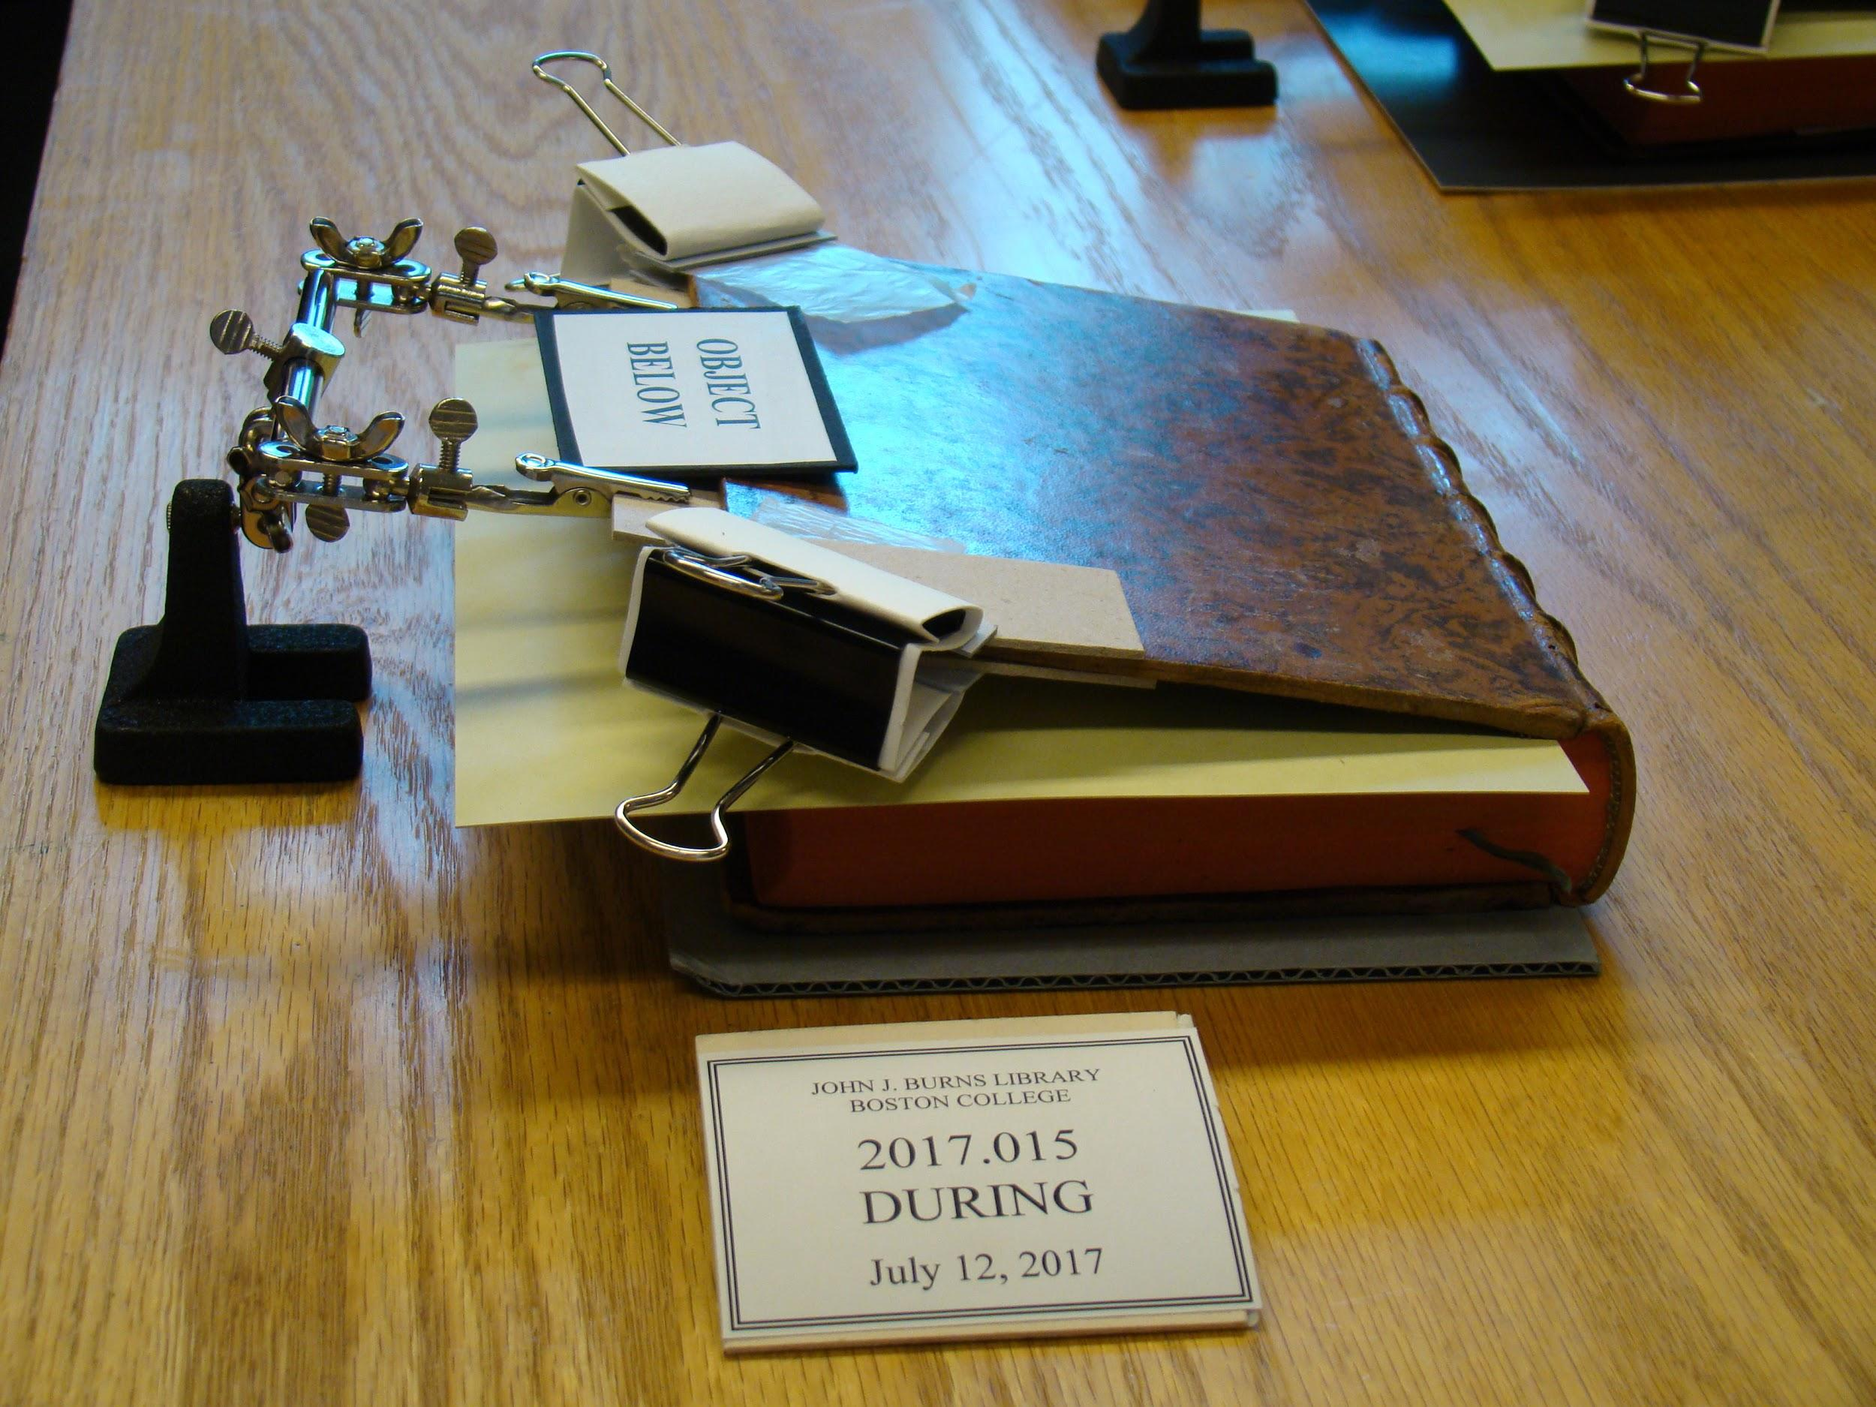

After:

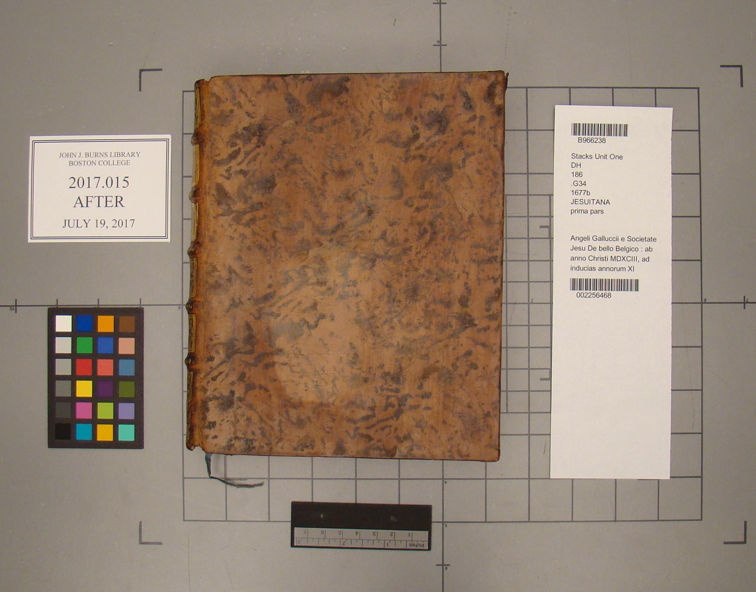

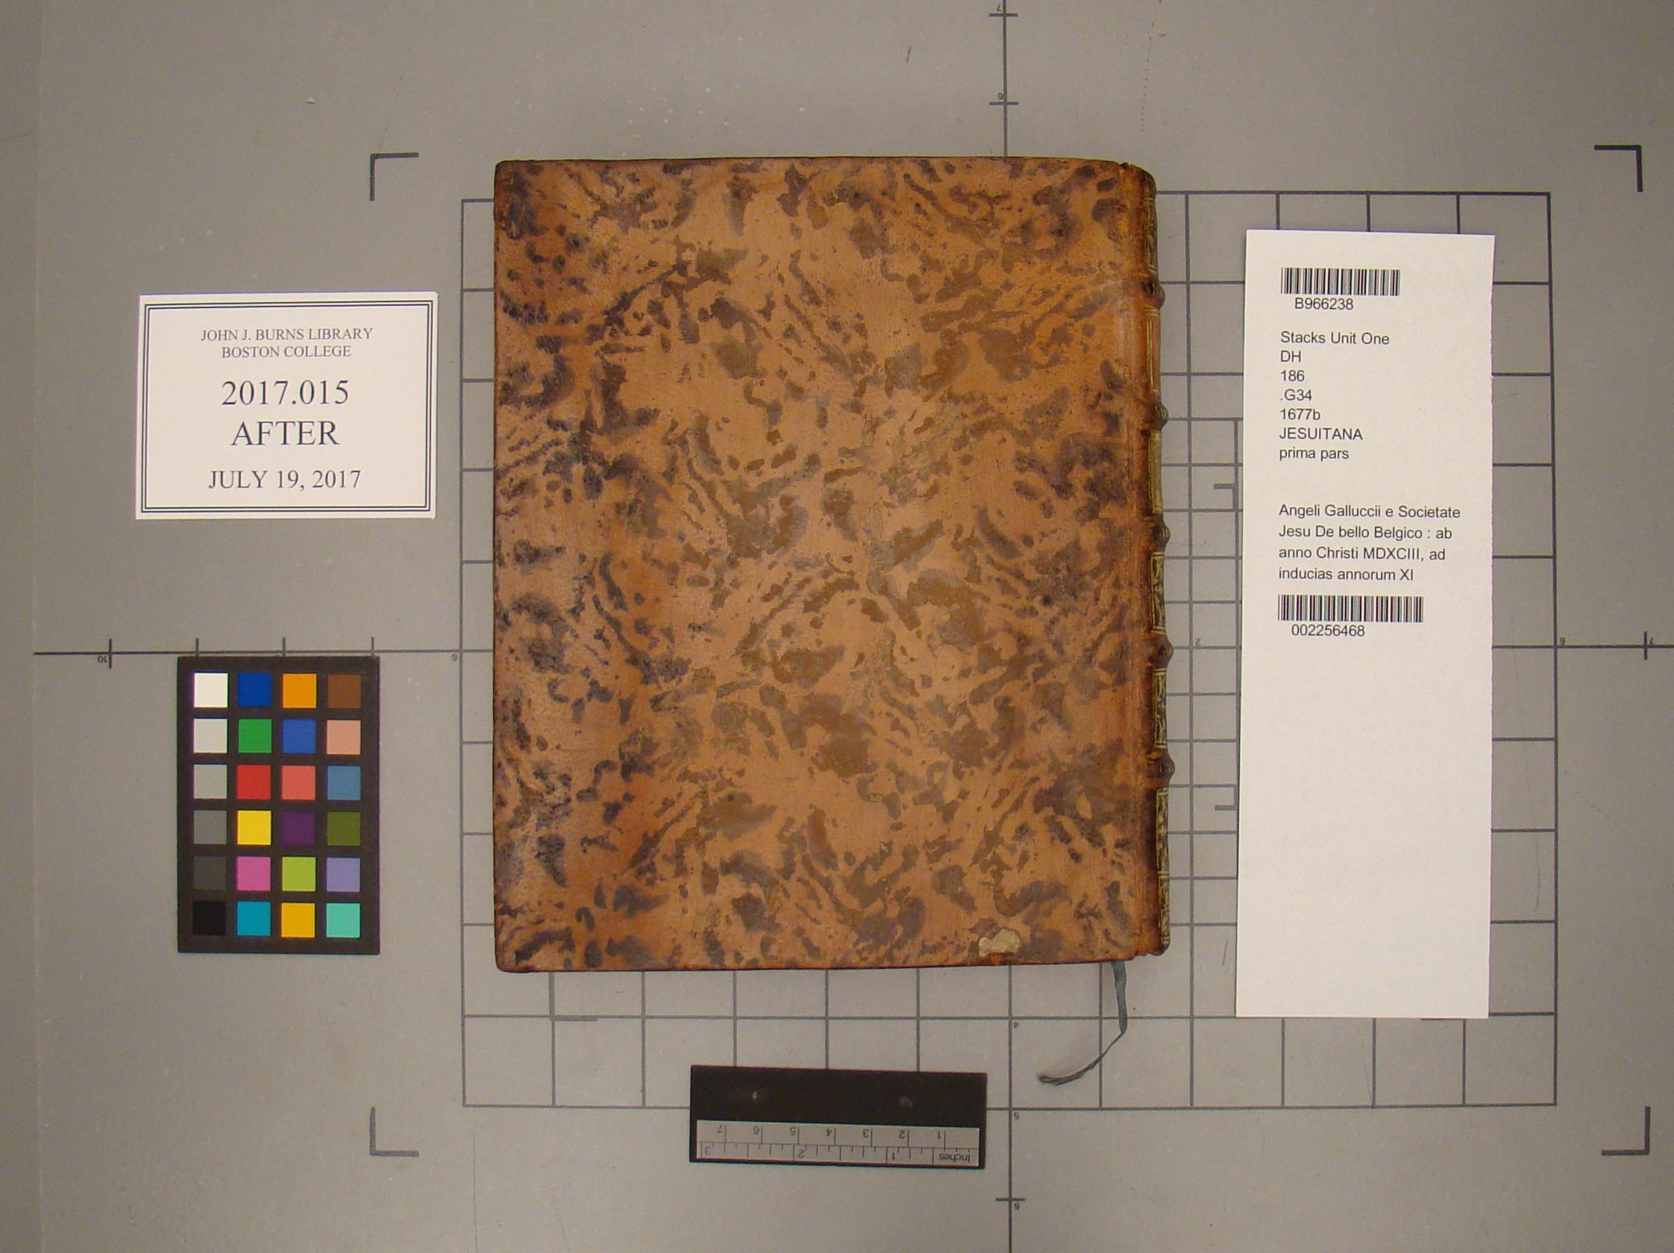

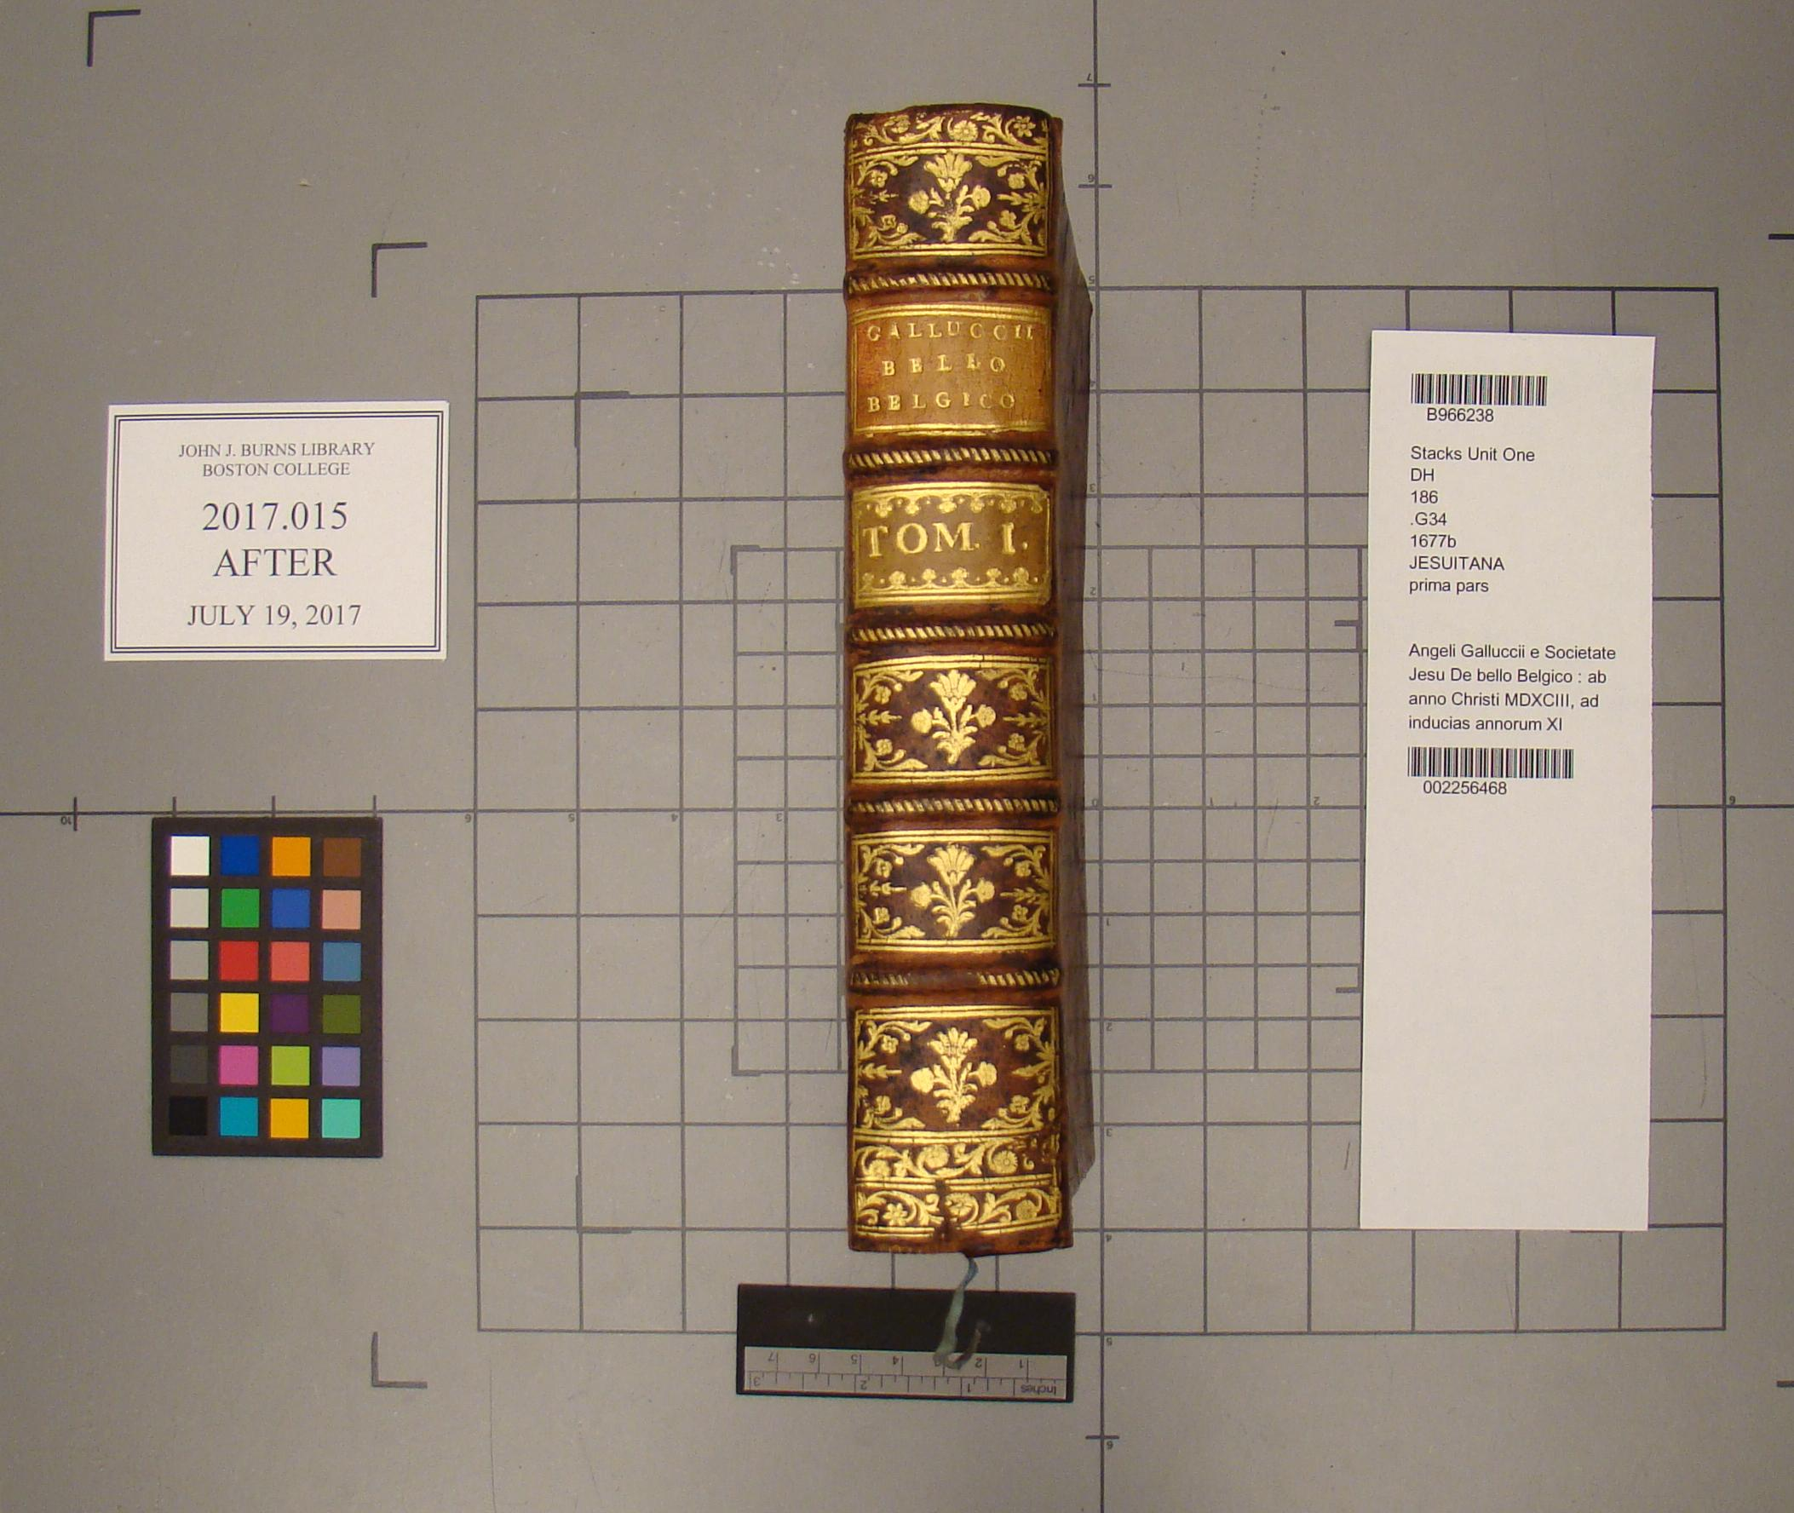

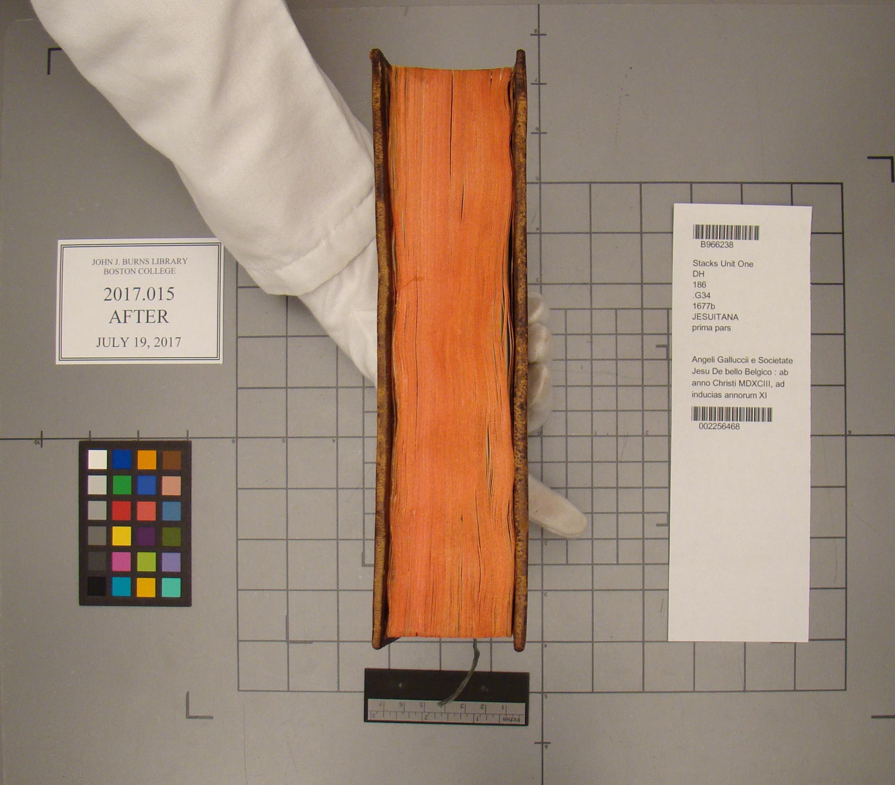

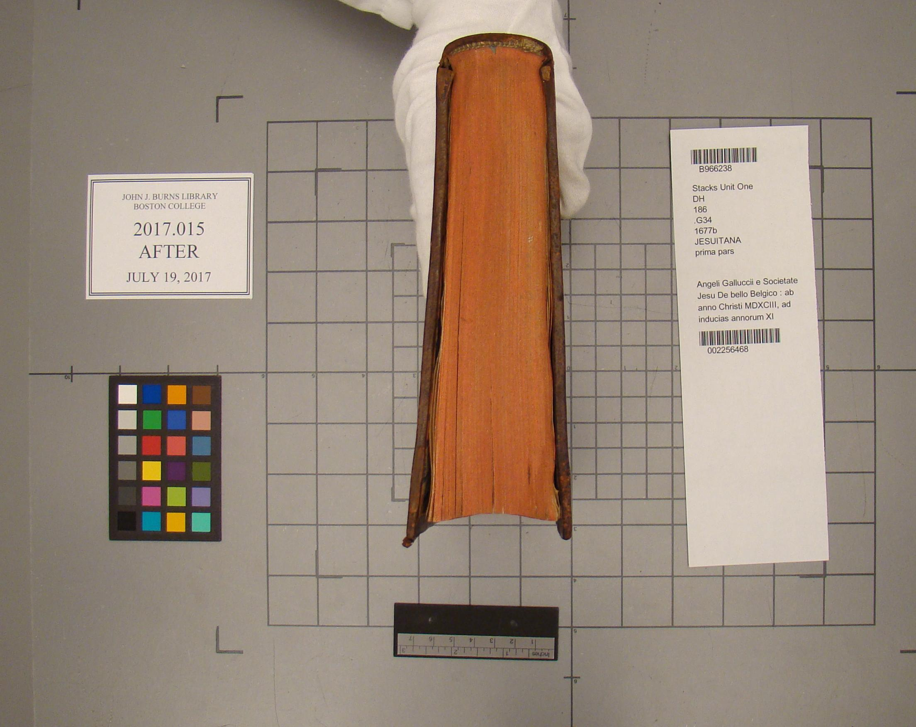

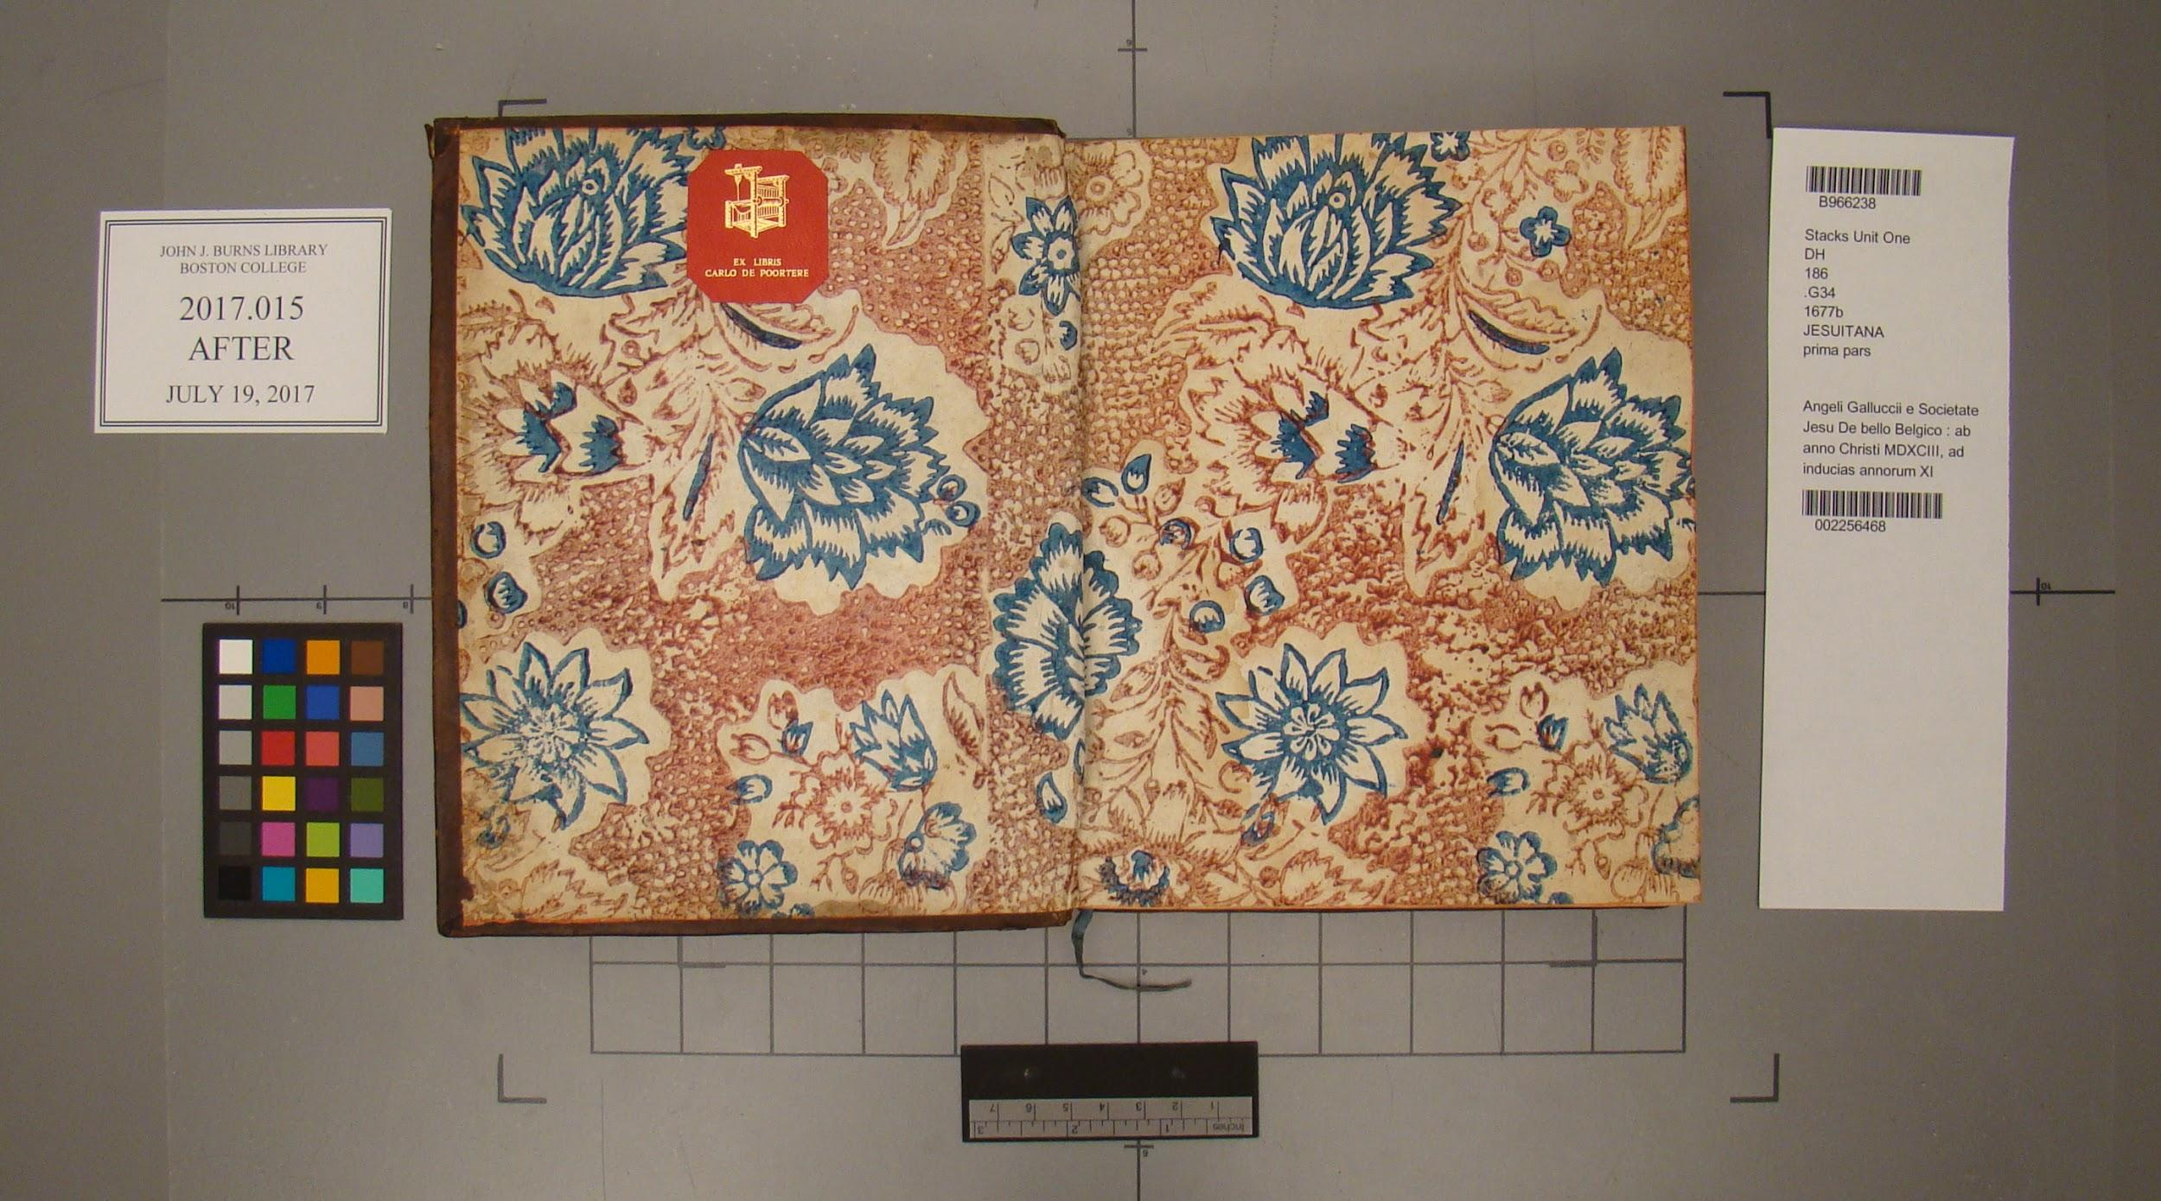

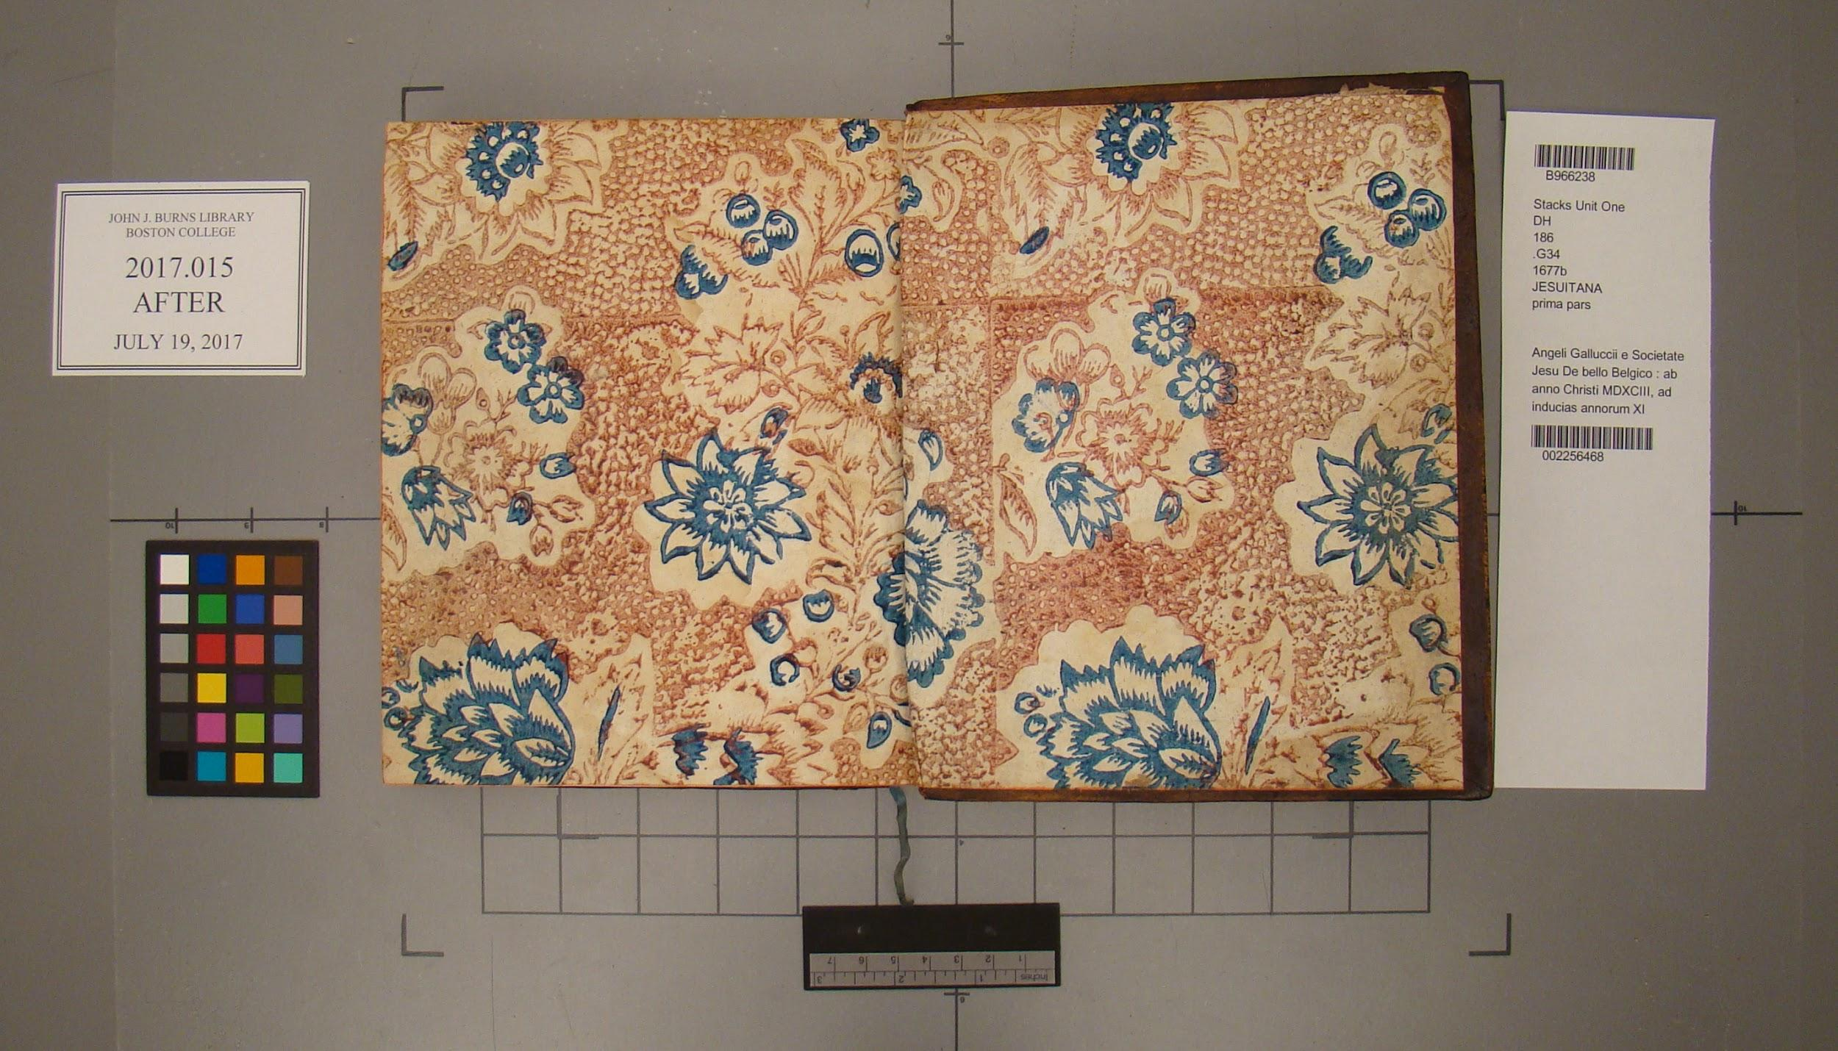

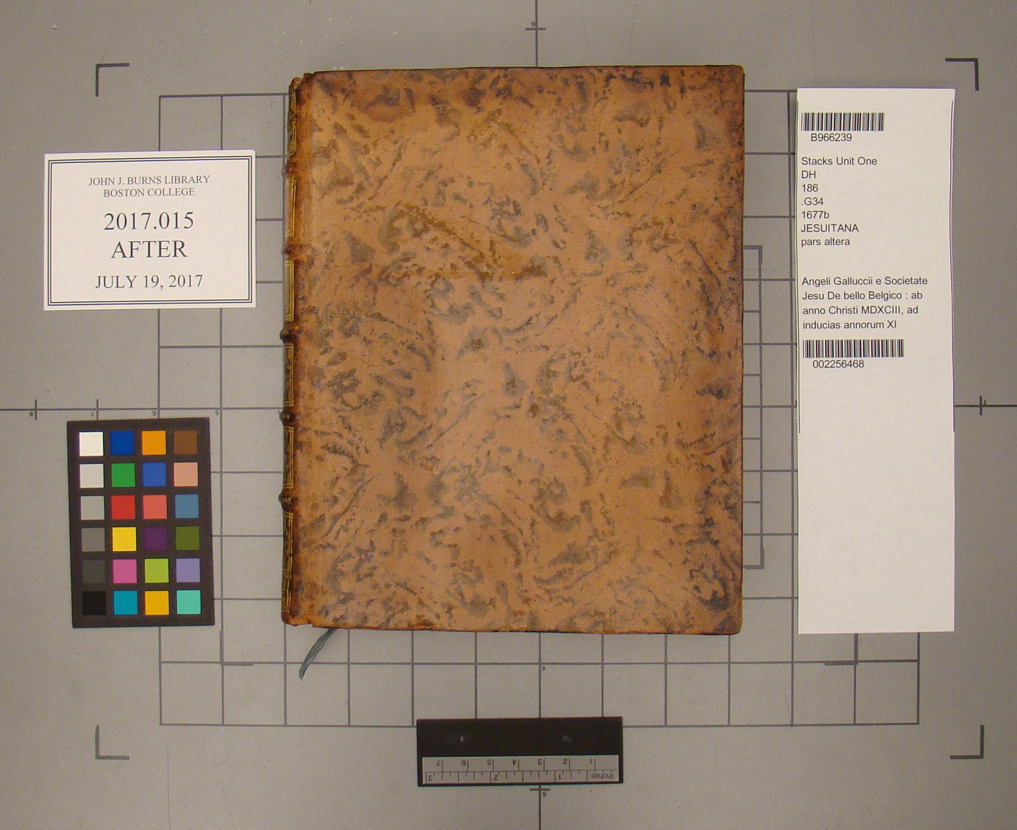

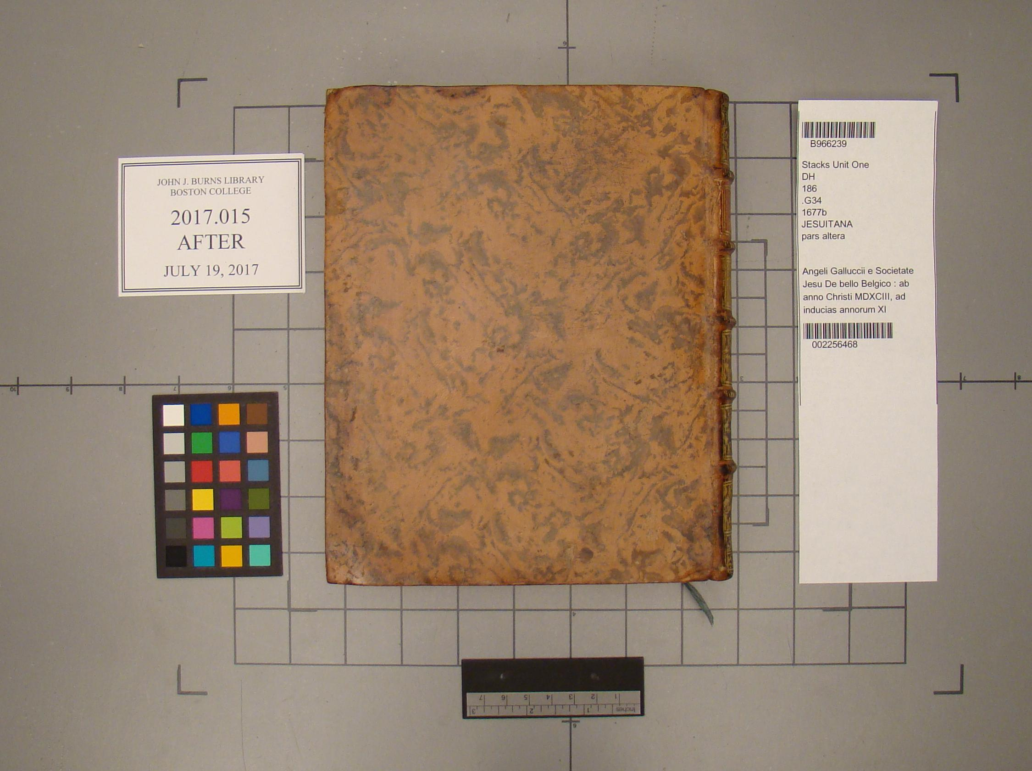

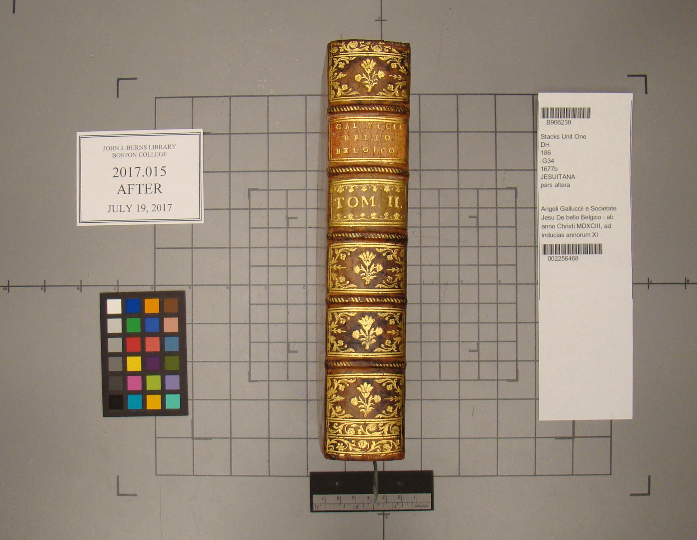

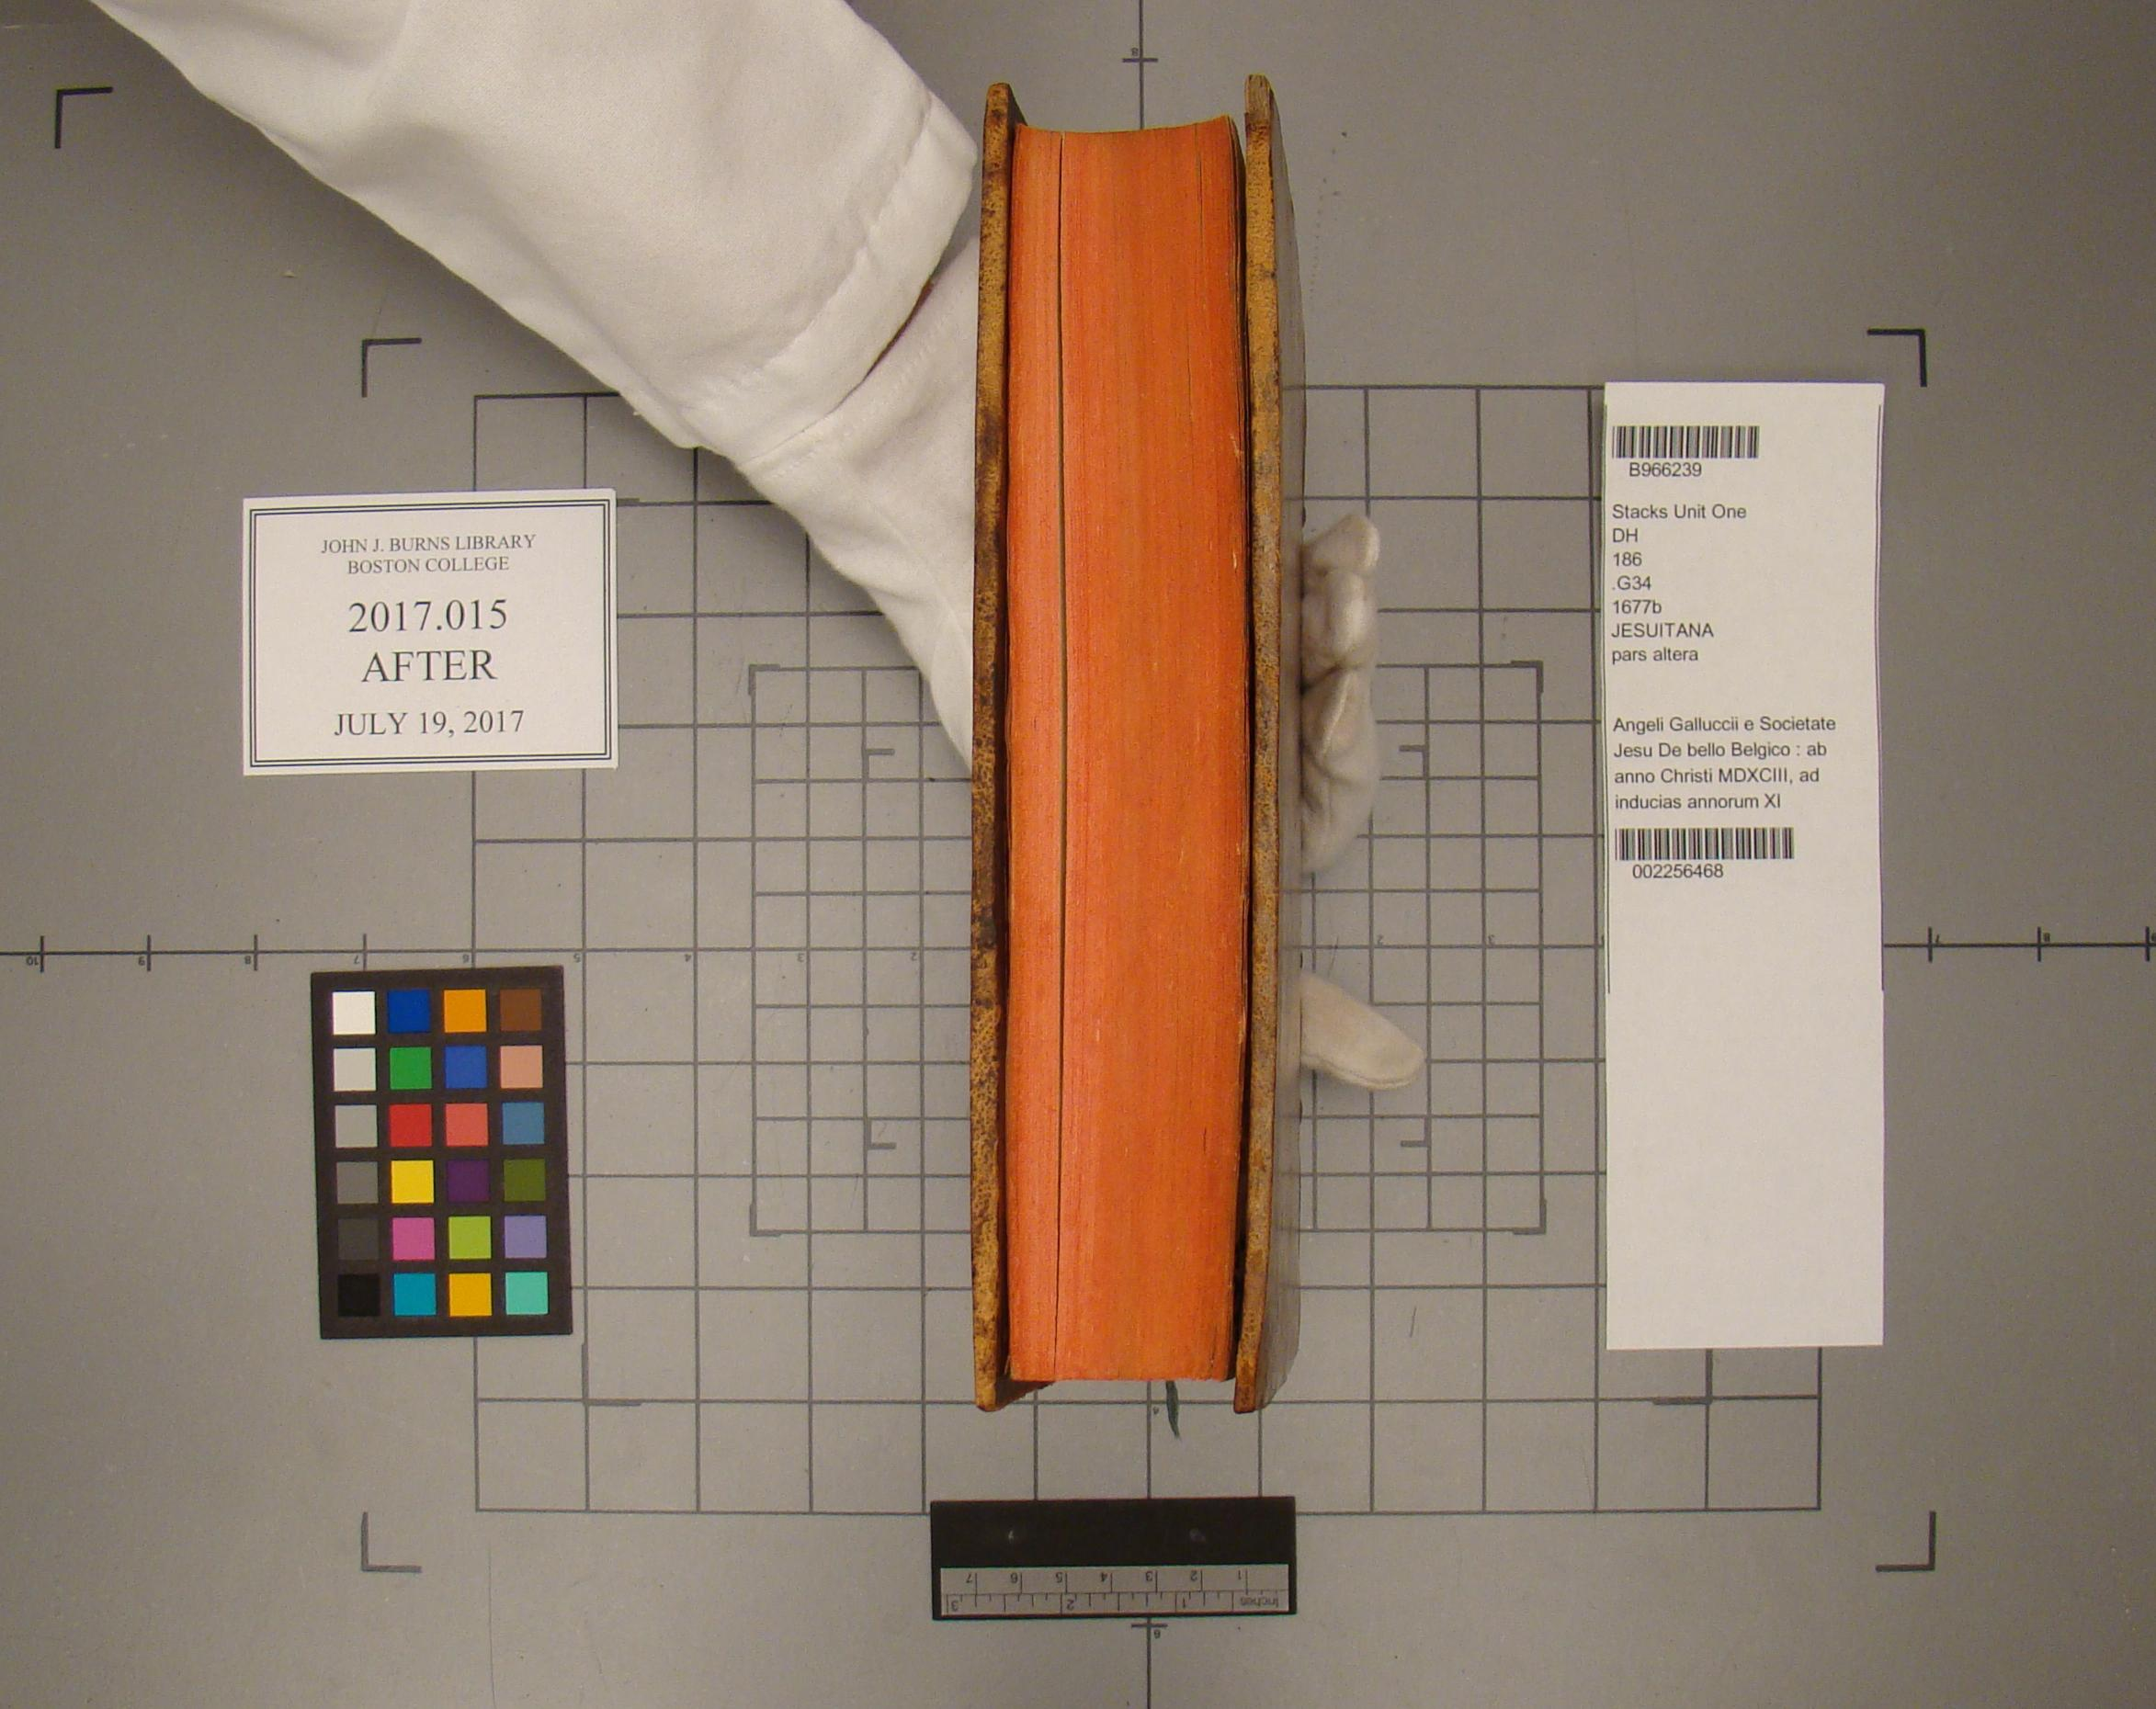

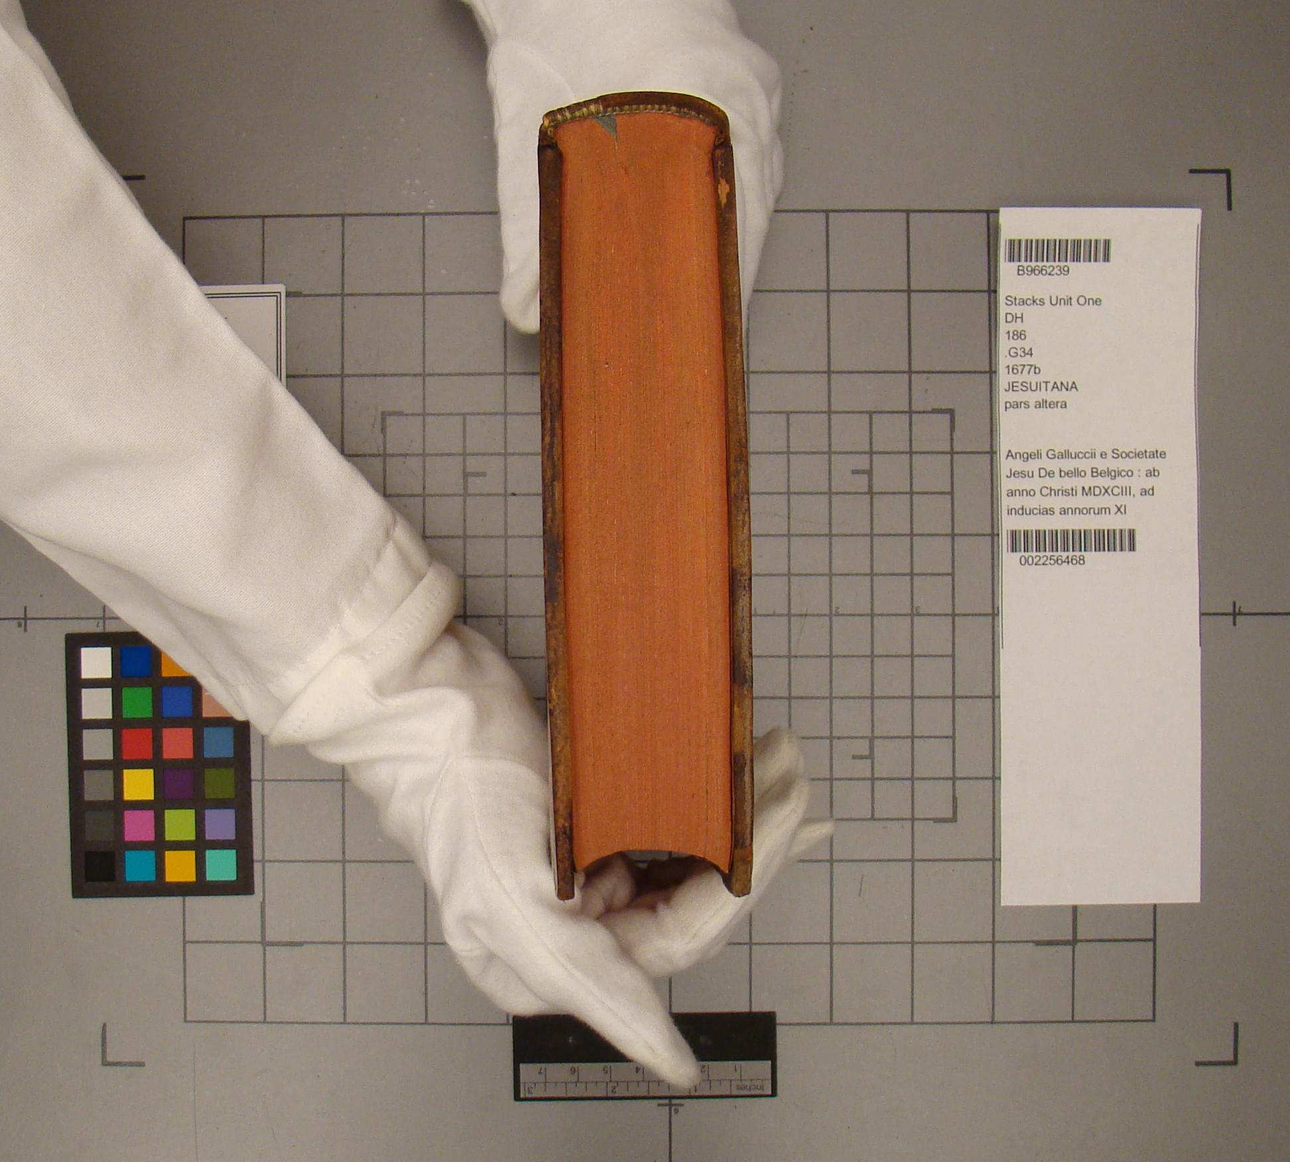

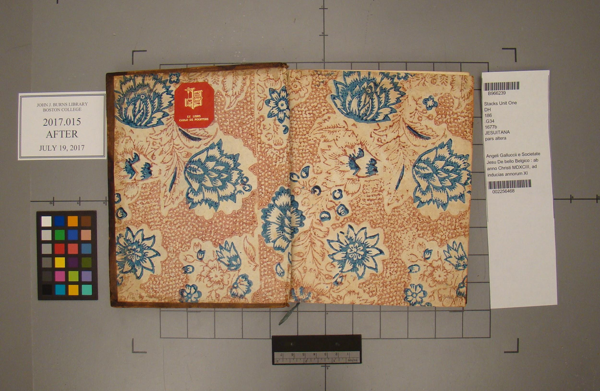

**Ephemera** N/A